Pupil premium strategy statement – Ancaster Church of England Primary School
This statement details our school’s use of pupil premium (and recovery premium) funding to help improve the attainment of our disadvantaged pupils.
It outlines our pupil premium strategy, how we intend to spend the funding in this academic year and the outcomes for disadvantaged pupils last academic year.

School overview
Detail | Data
Number of pupils in school | 41
Proportion (%) of pupil premium eligible pupils | 21.4%
Academic year/years that our current pupil premium strategy plan covers (3 year plans are recommended – you must still publish an updated statement each academic year) | 2023-2026
Date this statement was published | December 2025
Date on which it will be reviewed | December 2026
Statement authorised by | Lucy Jackson Headteacher
Pupil premium lead | Hayley Footitt (Assistant Head and Pupil Premium Lead)
Governor / Trustee lead | Adrian Reed

Funding overview
Detail | Amount
Pupil premium funding allocation this academic year | £ 60,600
Recovery premium funding allocation this academic year  Recovery premium received in academic year 2023/24 cannot be carried forward beyond August 31, 2024. | £
Pupil premium funding carried forward from previous years (enter £0 if not applicable) | £ 9,966.89
Total budget for this academic year  If your school is an academy in a trust that pools this funding, state the amount available to your school this academic year | £ 70566.89

Part A: Pupil premium strategy plan

Statement of intent
Our Church School Vision.
In the spirit of St. Martin, the Centurion Saint, we are a welcoming and inclusive community where every individual is celebrated.
As we journey together through exploration and learning, our curriculum strives to promote local and global citizens who realise they have the power to change.
Our high expectations for all, underpinned by our core Christian values of Wisdom, Courage and Respect, allow us to challenge everybody to be the best they can be.
Our “Guiding Lights” help us to ensure our Vision continues to help us root the work we undertake back into the vision. These guiding lights are central to the work we do across the school into our policies, systems, and processes, which are shaped by them as we look through each lens to improve and develop our school further. Our four Guiding Lights are:
Inclusivity Exploration Empowerment Values Led
These Guiding Lights will shape our curriculum as we promote a love of learning that is broad and balanced, rich and varied and offers all of our pupils a learning journey that ensure they develop the knowledge, skills, experiences, attitudes and beliefs to become confident and passionate future citizens of the world.
Guided by these lights, all of our members of staff and the governing body accept responsibility for ensuring the progress of all of our children and are committed to meeting their pastoral, social and academic needs within a safe and nurturing environment. We want each child to develop a love of learning and are given the chance and opportunity to reach their full potential and be the best that they can be.
We recognise that some of our Pupil Premium children will face challenges and through our values and our vision we are determined that we will together overcome these challenges and ensure that every child reaches their full potential.
We know that some of our children do not have the same opportunities as their peers outside of school. Through our enriched and experiential curriculum we will provide opportunities through key activities that will focus areas of our pupil premium expenditure (as set out below) to provide support for their social and emotional development.
We are all champions for our Pupil Premium children and are relentless in our support. We are relentless in our efforts to ensure that Pupil Premium children will develop good habits of attending school and intervene swiftly when attendance drops. We do not want our children to miss any opportunities that we provide each day, wherever possible.
Our curriculum aims to enable children to reach their full potential and be the best they can be both academically and in terms of personal development, ensuring that when they leave us they are prepared for the next stage of their education and are well-rounded individuals.
Our targeted and strategic use of Pupil Premium supports us in achieving our school aims for all our
pupils to develop into happy, well-rounded individuals who reach their own full potential. We plan to spend our funding by enhancing the educational experiences of children eligible for Pupil Premium Funding which frequently has an additional positive impact on other members of the school community, both in academic advancement and experiential enrichment.
Our aim is to close the attainment gap between PP and Non -PP children by meeting the academic, social and pastoral needs of children in receipt of PP funding and ensuring these barriers are overcome.
In order to achieve this aim, we will:

- ensure that the overarching responsibility for PPG expenditure and impact is overseen by a Senior Leader and member of the Governing Body;
- ensure that all members of the teaching staff are held accountable for the progress of PP children in their classes;
- guarantee all PP children have full access to the curriculum by ensuring that academic, social and pastoral barriers are overcome;
- ensure that children are taught by effective teachers who deliver high quality teaching daily;
- targeted provision for PP pupils that is based on an analysis of individual needs;
- involve the SLT and Governing body in ensuring that the use of this funding contributes to pupil achievement and attainment in English and Mathematics;
- analyse our data with a focus on the performance of PP children in relation to Non- PP children in English and Mathematics to inform future actions;

Our strategy incorporates the tiered model as outlined by the EEF as best practice:

Tier 1: High Quality Teaching
- We have focused on further improving quality first teaching, including the mastery principles, to ensure that all children receive effective teaching which meets their needs. We have strengthened our lesson design to incorporate a focus on retrieval of prior learning so that children know more and can remember more as well as the explicit teaching of vocabulary to extend spoken and written language.

Challenges
This details the key challenges to achievement that we have identified among our disadvantaged pupils.
Challenge number | Detail of challenge
1 | SEND  Around 50% of our SEND children are also in receipt of the Pupil Premium Grant. We are consistently above national average for children with SEND and EHCP support (22.45% at Ancaster compared to 13% in all school in England 22/23). Childrens’ needs vary greatly but include speech and language, dyslexia, dyscalculia, ADHD and ASD.
2 | Attendance  Attendance is lower for children in receipt of the pupil premium grant and sits at 93.3% compared to non- pupil premium children such as 95.2%. School are working on a 96% target for attendance.
3 | SEMH support  A high proportion of our PPG children also have SEMH needs and require additional support in school.
4 | Educational Attainment  Data for pupil premium attainment and progress shows an increasing gap between disadvantaged and non-disadvantaged pupils particularly in maths. We recognise through assessment it is the arithmetic that is letting our children down. End of KS2 data shows the combined total working at ARE, is lower for disadvantaged pupils.

Intended outcomes
This explains the outcomes we are aiming for by the end of our current strategy plan, and how we will measure whether they have been achieved.
Intended outcome | Success criteria
SEND  To improve the educational outcome for SEND children to ensure they are meeting their fullest educational potential. | Send children’s academic and non-academic will be carefully tracked to ensure they are meeting their fullest potentials.
SEND  To track their non-academic progress through an assessment programme | A chosen assessment system which will be effectively used to ensure children’s SEND targets are easily tracked and measurable.
Attendance  To raise attendance for disadvantaged pupils to align with non-disadvantaged, whole school figure of 96% | Disadvantaged pupils’ attainment will be carefully tracked and monitored to ensure it is on or as close to 96% as possible.
SEMH support  Clear process and strategies in referring children for additional SEMH support outside of the classroom. | Pupils’ SEMH needs are met within school and referral system is in place
Educational outcomes  Increase arithmetic outcomes for all pupils to raise maths attainment to help contribute towards combined results increase. | Across KS2 disadvantaged pupils’ outcomes within maths are impacted and ensuring the majority of children are meeting ARE.

Activity in this academic year
This details how we intend to spend our pupil premium (and recovery premium) funding this academic year to address the challenges listed above.

Teaching (for example, CPD, recruitment and retention)
Budgeted cost: £ 43,643.60
Activity | Evidence that supports this approach | Challenge number(s) addressed
Mastery teaching embedded in lesson designs across the curriculum for higher outcomes for all pupils.  Subject leader coaching alongside assistant head.  (1/2 day release for AHT + CT release)  £165 x 24 =£3,960  £116 x 24 = £2,784) | EEF: https://educationendowmentfoundation.org.uk/education-evidence/teaching-learning-toolkit/mastery-learning.  “The quality of teaching is arguably the single most important thing that teachers and leaders can focus on to make a difference in children’s learning. The difference between really good teaching and less effective teaching makes more difference to learning than any other factor within school. High-quality teaching narrows the advantage gap. Crucially, it is also something that can be changed”. EEF | 1,2,4
Phonics scheme annual up keep  Annual subscription and annual buying of phonics materials  (£1,200) | EEF: Phonics | EEF (educationendowmentfoundation.org.uk)  “Phonics has a positive impact overall (+5 months) with very extensive evidence and is an important component in the development of early reading skills, particularly for children from disadvantaged backgrounds”. EEF | 1,4
Prioritising 2 fulltime adults in classes across KS1 for all AM and PM to further support towards curriculum achievement and SEMH support  (£13,928) | EEF: Teaching Assistant Interventions | EEF (educationendowmentfoundation.org.uk) | 1,2,4
KS2 TA support to deliver high quality interventions across KS2 classes within maths and English  (£13,928) | EEF: Teaching Assistant Interventions | EEF (educationendowmentfoundation.org.uk) | 1,2,4
Delivery of internal and external CPD opportunities to continually improve the quality of teaching and learning  (Kyra - £140  Diocese  L.E.A.D  Keystone academy Trust assessment and moderation £200) | Effective Professional Development – EEF Effective Professional Development plays a crucial role in improving classroom practice and pupil outcomes. “Ensures that every teacher is supported in delivering high quality teaching to achieve the best outcomes for all pupils and particularly the disadvantaged pupils” EEF | 4
Purchased whole school PSHE scheme to uplevel the PSHE teaching within school and further support SEMH needs.  (Training, annual subscription and resources £995) | EEF: Social and emotional learning | EEF (educationendowmentfoundation.org.uk)  “Social and emotional learning approaches have a positive impact, on average, of 4 months’ additional progress in academic outcomes over the course of an academic year”. EEF | 3,4
SEND support from SENDco to class teachers through whole class observations, meetings, 1:1 work with children to identify barriers for learning and creating support plans with teachers  (1/2 day SENDCO wage  £148 x 38 = £5,624) | EEF: Individualised instruction | EEF (educationendowmentfoundation.org.uk)  “Individualised instruction can be an effective approach to increasing pupil attainment”. EEF | 1,3,4
White Rose maths  (£489.60) | White Rose Maths :  At White Rose, we understand the pivotal role that teachers and educators play in shaping the future lives of young people. Our resources, meticulously designed by expert teachers, reflect a commitment to excellence.Rooted in research on the teaching for mastery approach, we provide a comprehensive progression for pupils aged 4 to 16, a rich bank of teaching resources and engaging professional development to inspire and empower individuals and teams. | 4
Test base assessments  (£395) | EEF: Embedding Formative Assessment | EEF (educationendowmentfoundation.org.uk) | 4

Targeted academic support (for example, tutoring, one-to-one support, structured interventions)
Budgeted cost: £ 5,088.80
Activity | Evidence that supports this approach | Challenge number(s) addressed
Annual subscription for IDL programme to support reading, spelling and maths for dyslexic/dyscalculia pupils  (annual subscription £999) | IDL Effectiveness Study found that “IDL produces significantly faster reading and spelling related improvements that non-specialist teaching methods – with an average 10 months improvement in spelling after just 26 hours on the IDL programme. | 1,4
Purchased intervention programme ‘Catch up numeracy and catch up literacy’ to further support TA intervention  (£495 + £495) | EEF: Teaching Assistant Interventions | EEF (educationendowmentfoundation.org.uk) | 1,4
Times table rockstars for targeted times table support to increase children’s mathematical fluency. Numbots programme to support Ks1 number fluency.  (£189.80) | EEF: Individualised instruction | EEF (educationendowmentfoundation.org.uk)  “Individualised instruction can be an effective approach to increasing pupil attainment. There is evidence that digital technology can be used effectively to provide individualised instruction. Many of these studies use digital technology alongside small group tuition”. EEF | 1,4
HLTA costing to release class teachers to provide high quality intervention for disadvantaged/lower attaining pupils  (38x ½ rate HLTA  38 x £76.58 = £2,910) | EEF: Mentoring | EEF (educationendowmentfoundation.org.uk)  “Some evidence suggests that some pupils from disadvantaged backgrounds show low engagement with or have low expectations of schooling. Mentoring interventions may be more beneficial for these pupils, as the development of trusting relationships with an adult or older peer can provide a different source of support”. EEF | 1,4

Wider strategies (for example, related to attendance, behaviour, wellbeing)
Budgeted cost: £19,105.65
Activity | Evidence that supports this approach | Challenge number(s) addressed
Counsellor and staff members trained with ELSA and thrive  (£38 x 2 x 28 = £1,900  ELSA + Thrive = £813.45) | EEF: Social and emotional learning | EEF (educationendowmentfoundation.org.uk)  “Social and emotional learning approaches have a positive impact, on average, of 4 months’ additional progress in academic outcomes over the course of an academic year”. EEF  Thrive :  https://www.thriveapproach.com/impact-and-research Thrive: “Thrive gives staff the ability to identify needs and track progress at a multi-site, single site, classroom, and individual level. Through Thrive training, staff will gain a better understanding of behaviour in children and young people, and the reasons for that behaviour, enhancing their capacity, confidence, and commitment to working with children from all backgrounds, including those with the most complex needs”. | 3
Pastoral TA support to deliver ELSA and Thrive sessions  (2 ½ days for HLTA  2 x £2,910 = £5,820) | EEF: Social and emotional learning | EEF (educationendowmentfoundation.org.uk) | 3
Mental health and well-being lead introduced into school  (£480) | EEF: Social and emotional learning | EEF (educationendowmentfoundation.org.uk) | 1,3
Team teach training  (£344) | EEF: Behaviour interventions | EEF (educationendowmentfoundation.org.uk)  “Both targeted interventions and universal approaches have positive overall effects (+ 4 months). Schools should consider the appropriate combination of behaviour approaches to reduce overall disruption and provide tailored support where required”. EEF | 1,3
BOSS training twilight training for all staff  (£692) | EEF: Behaviour interventions | EEF (educationendowmentfoundation.org.uk)  “Both targeted interventions and universal approaches have positive overall effects (+ 4 months). Schools should consider the appropriate combination of behaviour approaches to reduce overall disruption and provide tailored support where required”. EEF | 1,3
TA to deliver sensory circuits for children that struggle to regulate within the classroom  (1x ½ day TA)  £52,80 x 38 = £1,003.20) | EEF: Behaviour interventions | EEF (educationendowmentfoundation.org.uk)  “Both targeted interventions and universal approaches have positive overall effects (+ 4 months). Schools should consider the appropriate combination of behaviour approaches to reduce overall disruption and provide tailored support where required”. EEF | 1,3
Extra mid-day staff to provide support and cover for behavioural/SEMH needs  (£3,053) |  | 1,3
Enrichment offering PP families have trips, clubs and music tuition paid for  (£4,000) | EEF:Arts participation | EEF (educationendowmentfoundation.org.uk)  “Overall, the average impact of arts participation on other areas of academic learning appears to be positive but moderate, about an additional three months progress.  Improved outcomes have been identified in English, mathematics and science.” EEF | 3,4
WARMTH approach  (up to £1000 for resources, training and staff time) | Barriers to Education: WARMTH Framework - Barriers to Education | 2,3

Total budgeted cost: £ 67,838.05

Part B: Review of the previous academic year

Outcomes for disadvantaged pupils
Please see below our whole school outcomes from EYFS, Year 1 phonics screening and end of KS2 outcomes. From this data, we have decided to prioritise maths attainment across school, with a particular focus upon arithmetic. Across, KS1 TAs and interventions are to be prioritised across Year 2 and Year 3 as 0 out 5 disadvantaged pupils achieved a combined pass within end of KS1 achievements.
EYFS outcomes:
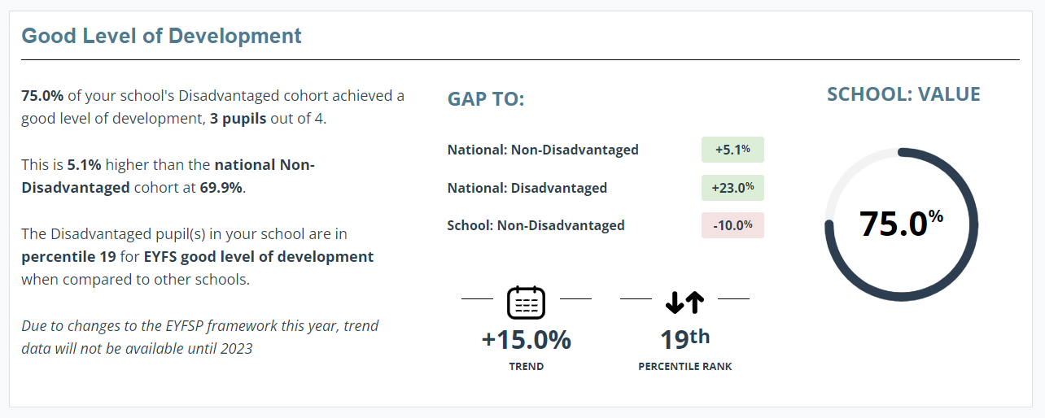
Year 1 Phonics outcomes:
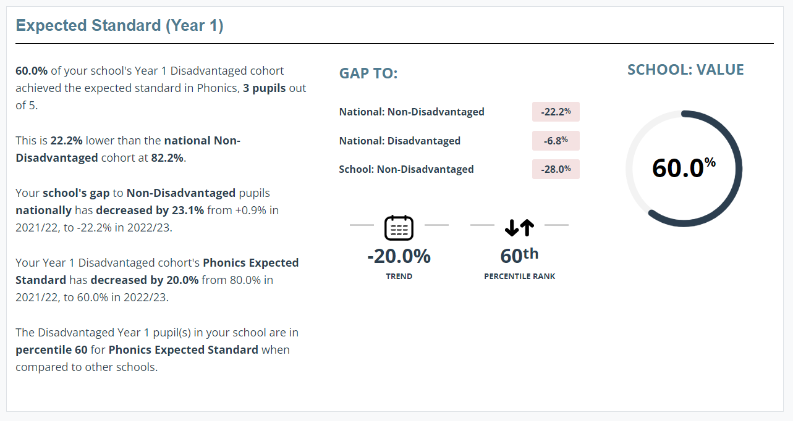
End of Key Stage 1 outcomes:
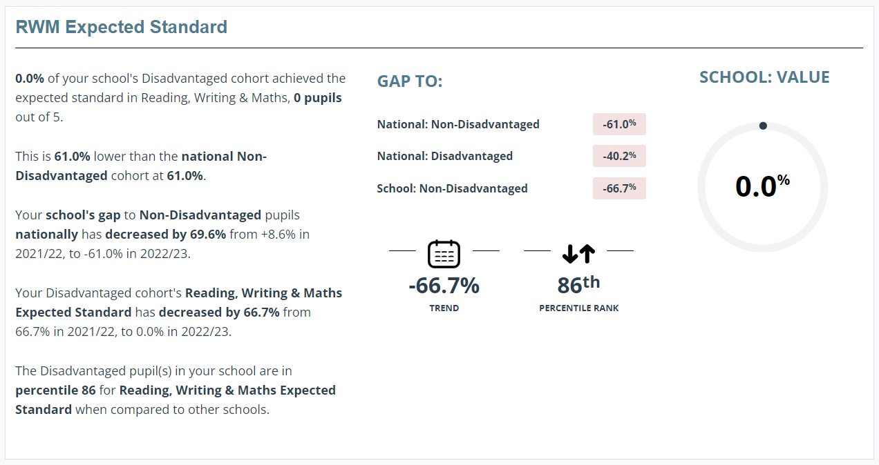
End of Key Stage 2 outcomes:
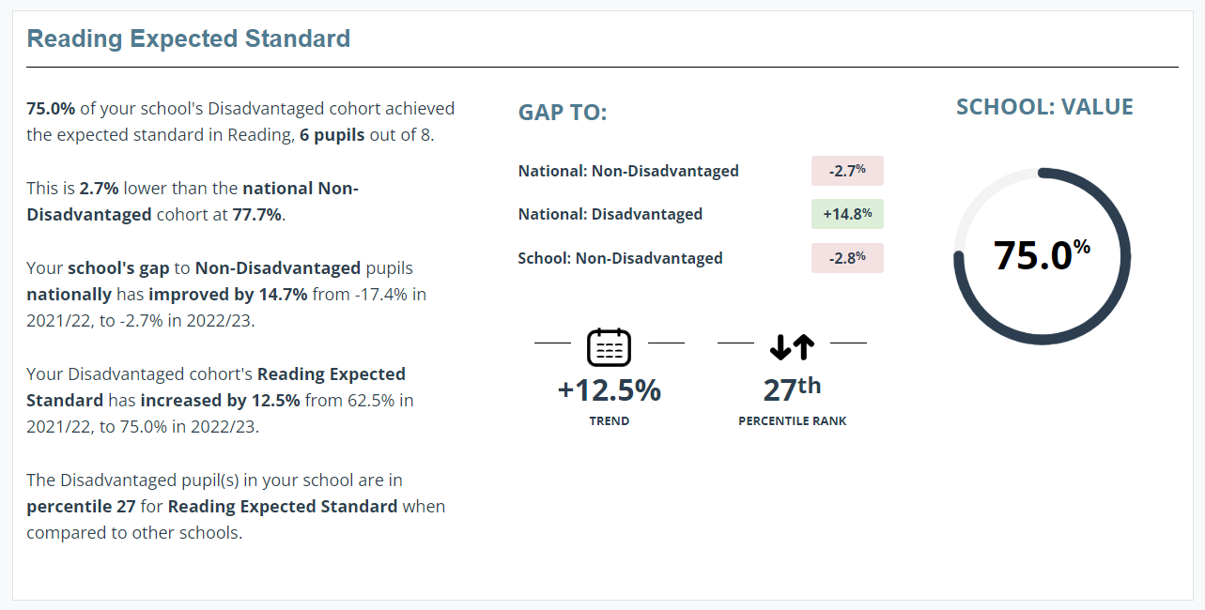
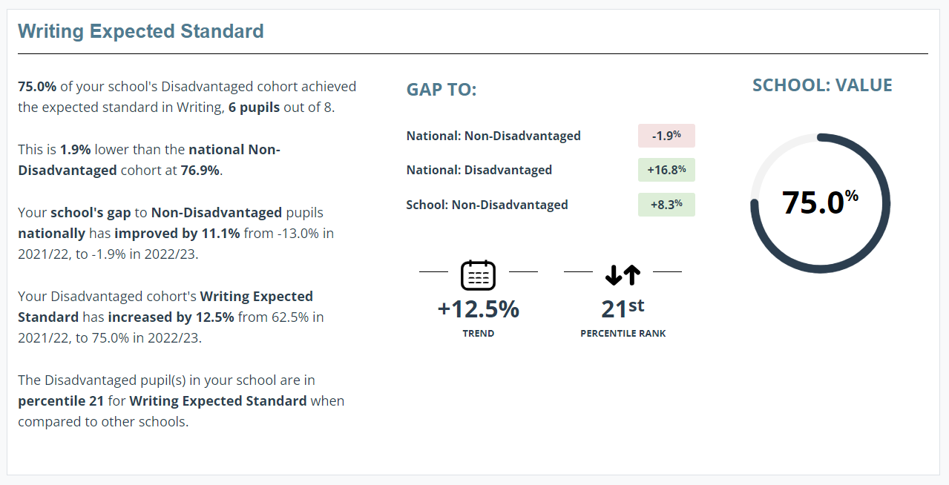
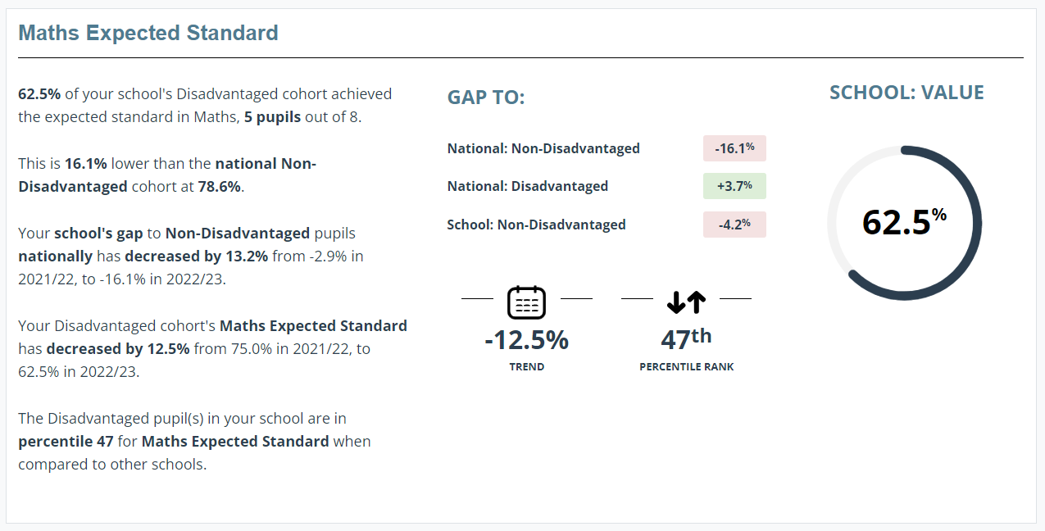
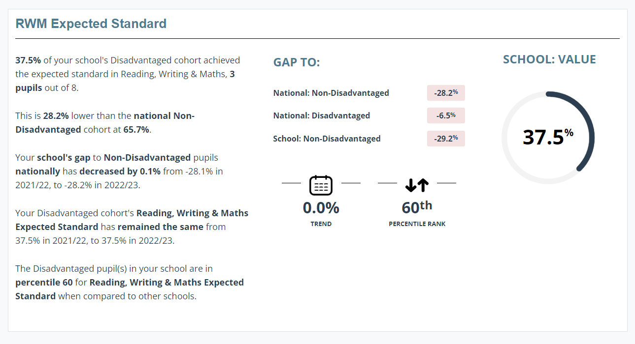

Externally provided programmes
Please include the names of any non-DfE programmes that you used your pupil premium (or recovery premium) to fund in the previous academic year.
Programme | Provider
IDL | IDLS Group
Thrive | Fronting the Challenge Projects Ltd
Numbots/times table rock stars | Maths Circle Ltd.
Catch up numeracy | The Caxton Trust
Catch up literacy | The Caxton Trust

