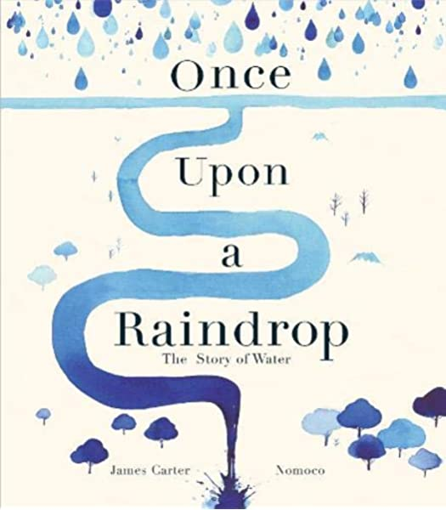
10th July
Writing
Re-listen to “Once Upon a Raindrop: The Story of Water” by James Carter https://www.youtube.com/watch?v=raXENZYwWXc
Learning Question
How do we write our own poem?
Outcomes
1.. Chrn to explore the life story of a river and write their own poem following the structure of this story
- Chrn to make a list of features at different stages of the course (source or spring, valley, rapids, waterfall, meander, floodplain, estuary…)

Task: Write a poem
In this lesson, you will explore the life story of a river and write your own free verse poem following the structure of this story.




