6th July
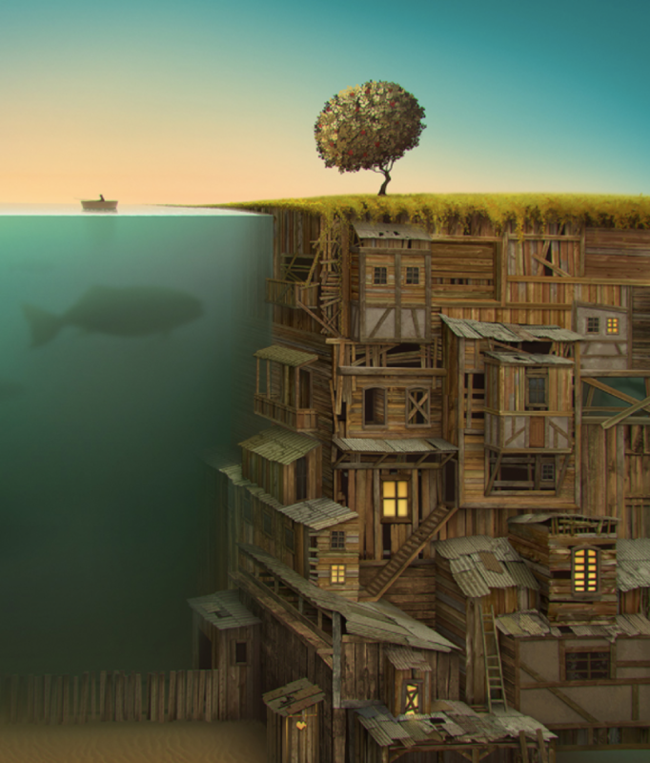
Writing

‘Underneath’
On the surface, everything looked ordinary.
The boy in the boat was bored. He had lived beside this boring river with his boring family for his whole boring life. Nothing unexpected ever seemed to happen to him. He often went to bed at night and wished for something exciting in his life.
Little did he know, underneath the ground he walked on and the river he rowed his boat on, a marvellous, mysterious, magical menagerie of life stirred.
His life was about to become a lot more interesting…

