9th July
Writing
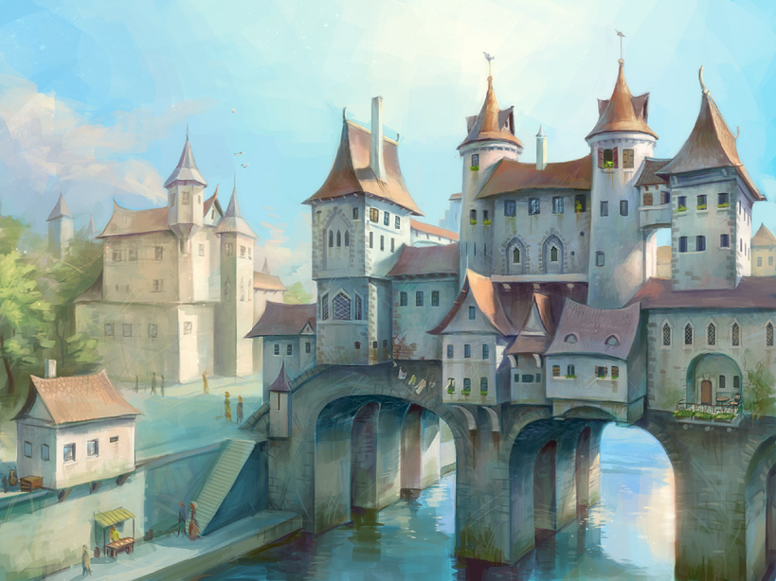

‘Over the River’
Questions to support your writing
- Describe this setting. Look for the details. [Can you see the bridge turning green near the water? Can you see the washing hung out over the river? Can you see the little stall by the river?]
- What do you think the building over the water is for? [Do people live there? Is it a workplace? A religious building? An entertainment venue?]
- Why did they build it there? What are the benefits of having a building over a river? Are there any disadvantages?
- What country do you think this is in? Why?
- Do you think this is the present day or the past? Why?
- Why are the people walking on the lower path by the river?

