Wednesday 22nd April 2020
Earth Day Research
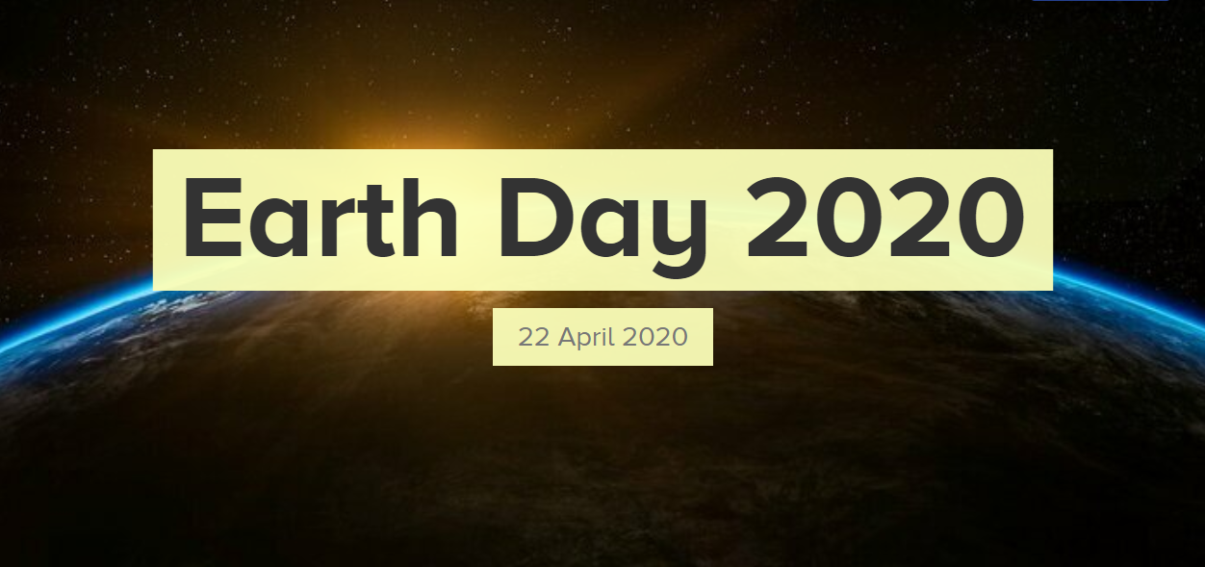

https://www.earthday.org/
Find out all you can about Earth Day and present it as you choose.
You may want to include:
- how and when Earth Day began;
- who the founder of Earth Day was
- the issues facing our planet eg climate change, plastics polluting the oceans and the extinction of some animals
- what we can do to help the planet
Some ideas for presenting your information are:
- creating a poster or drawing a picture to communicate your messages
- design a leaflet – include pictures, graphs and text
- powerpoint presentation
- comic strip or animation

Optional Writing Challenge:
If you want to, you can use your research to write a newspaper article about Earth Day.
More help on how to write newspaper articles can be found at BBC Bitesize website (link below)
https://www.bbc.co.uk/bitesize/articles/zkn3bdm

I look forward to seeing your work!

