Factors Problem Solving Task
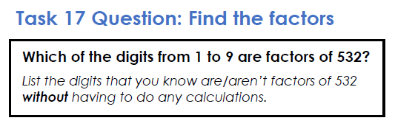

Use the prompts below as relevant to help you find the answers. Think about working systematically.
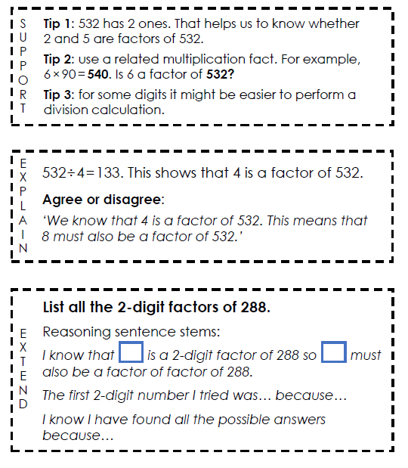

Answers are on page 2!
Answers
