Journey to school.
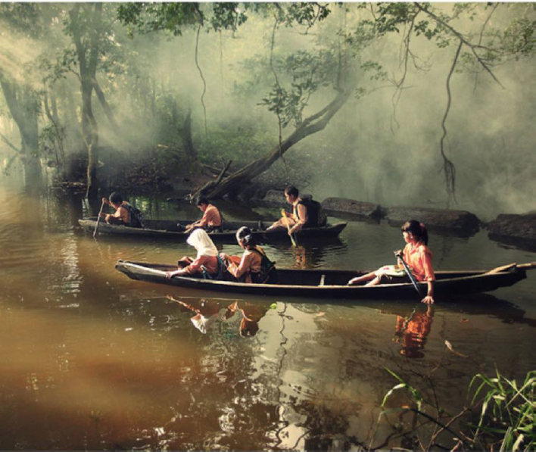
The children in the picture below, travel to school on a boat, every day. Imagine you are one of the children in the picture. Can you write a diary entry as though you are one of the children about your journey to school?
Things to think about
How is their journey to school different to yours?
Where do you think they are?
How long do you think it takes them to get to school?
What do you think they all ate for breakfast?
What do they have inside their rucksack?
Where are their parents?
What is their school/teacher like? How is it similar/different to yours?

