Thursday 30th April 2020
Writing Task – Macbeth
What description have I used to describe the witches?
Look at the extract below from the original Shakespeare text, when Banquo describes the witches for the first time.
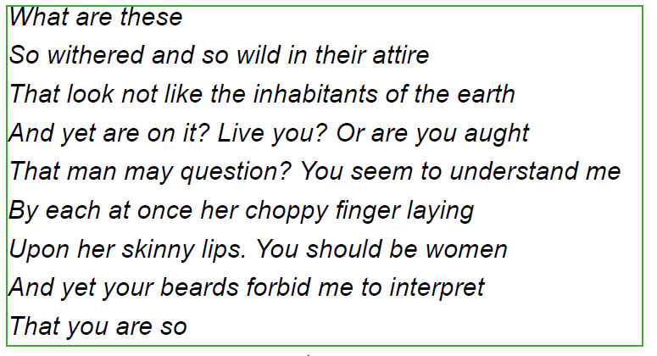

- Using your inference skills, what does this text tell you about the witches?

- HINT: not like inhabitants of the earth means that the witches do not look human. What physical characteristics are we told about?

- Draw a picture of each of the three witches using the text above to help you.
Make each witch different from each other eg one may be old and withered, one might be young, one may be a male witch.

- You can carry out some research into how the witches have been described in Macbeth productions and paintings.
You could use search terms such as: male witches in Macbeth, movie witches in Macbeth, young witches in Macbeth

- Write a description of your three witches using descriptive vocabulary such as similes, metaphors, expanded noun phrases

