Tuesday 12th May 2020
Writing Task: Shakespeare – Macbeth
Mystery words and Phrases
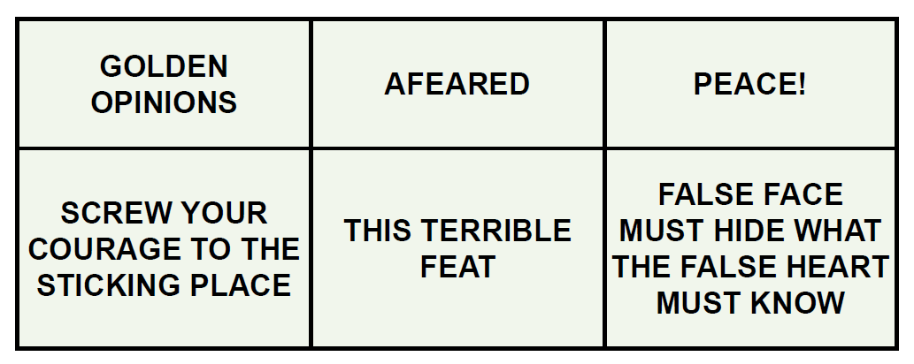

Watch episode 3 and use the context of the story to help you solve the meaning of these words and phrases. Use a dictionary if you need to!
Answers are on Page 2.

Answers
Golden opinions = high opinions (for his bravery in battle)
• Afeared = frightened
• Peace! = be quiet! Silence!
• Screw your courage to the sticking place = tighten your courage until it is as firm as a screw
hanging a picture on the wall (this is a tricky one but should generate some good discussion)
• This terrible feat = this awful deed or thing I must do
• False face must hide what the false heart must know = I must pretend to be friendly, knowing
that I am going to kill Duncan later tonight

