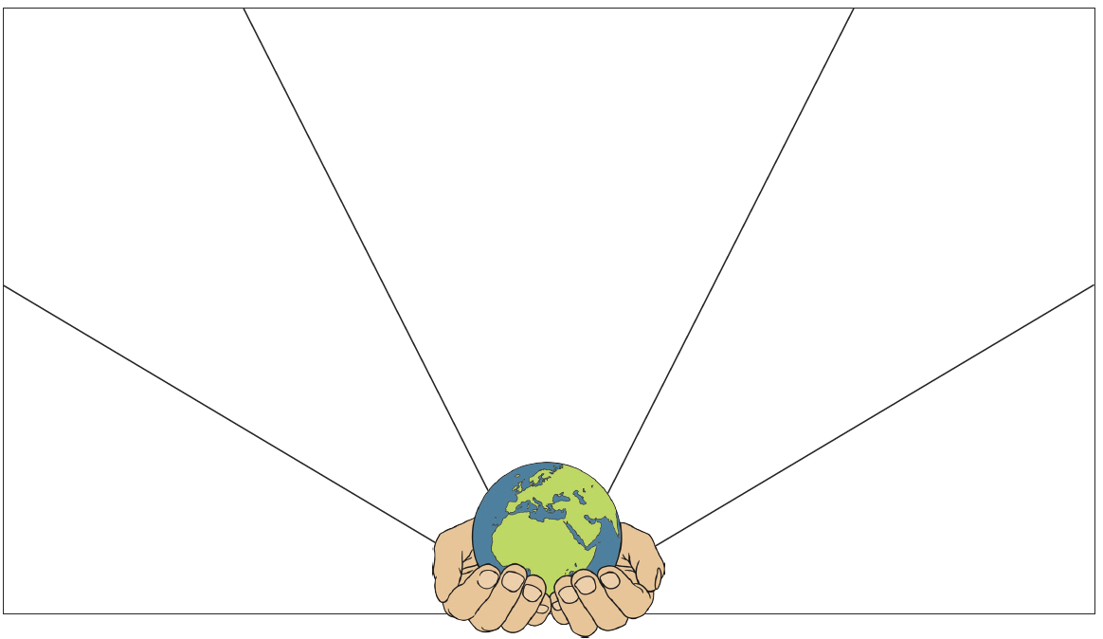
Make the world a kinder place.
Talk to an adult about how we can help to make the world a kinder place. Write your ideas in sentences around the globe.

