Time
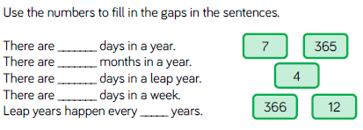
.

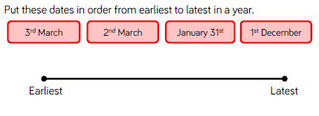

Reasoning and Problem Solving
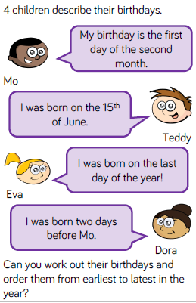

? 2020
Sunday | Monday | Tuesday | Wednesday | Thursday | Friday | Saturday
 |  |  | 1  Beginning of Advent | 2 | 3 | 4  Christmas Fayre
5 | 6 | 7 | 8 | 9 | 10 | 11
12 | 13 | 14 | 15 | 16 | 17 | 18
19 | 20 | 21  Nativity play | 22  School holiday begins | 23 | 24 | 25  Christmas day
26 | 27 | 28 | 29 | 30 | 31

Write the answers in your home learning books
- What month do you think this calendar is for?
- On what date is the Nativity play?
- What day is Christmas day on?
- What day is the 1st of the month?
- What day is the 28th?
- What day is the 10th?
- How many Thursdays are there in this month?
- How many Sundays are there in this month?
- What day would the 1st of the next month be?
- How many full weeks are there in this month?

