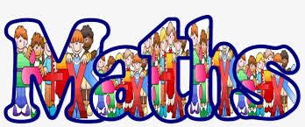

Measurement: Length and Perimeter
In these lessons, you will learn how to measure, compare, add and subtract: lengths (m/cm/mm); mass (kg/g); volume/capacity (l/ml).
Lesson 1
- In this lesson you are going to learn to use different measuring equipment including rulers, tape measures, metre sticks. You will discuss which equipment is the most appropriate depending on the object you are measuring.

Click on this to support your learning: https://www.bbc.co.uk/bitesize/topics/z4nsgk7
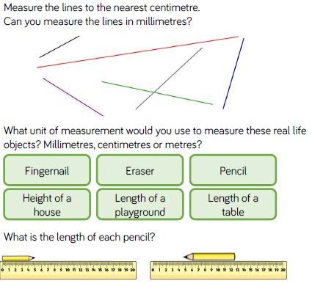
- Now solve these fluency questions below.

3. Now solve these problem-solving questions below.
