In these lessons, you will learn how to draw and discover equivalent fractions using diagrams. You will look at unit and non-unit fractions. You will also learn about how to simplify and find equivalent fractions.
Lesson 1
Equivalent Fractions: Drawing and Discovering
- In this lesson you are going to learn about equivalent fractions. Equivalent fractions are the same fraction written in different ways. You will use fraction walls, number lines and bar models to find equivalent fractions. This is an important skill for all the fraction work you will do in later years at school. You'll use fraction strips to show that ¹⁄₂ and ²⁄₄ are equivalent fractions.

Click on this to support your learning: https://www.bbc.co.uk/bitesize/articles/zm6rkxs

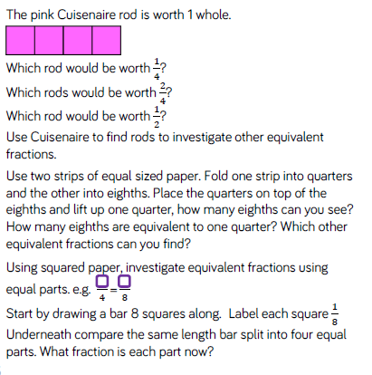
- Now solve these fluency questions below.

