Lesson 2
1. In this lesson, you will learn how to simplify and find equivalent fractions. 'Equivalent' means equal! Sometimes fractions look different, but they can show the same amount.
Click on this to support your learning: https://www.bbc.co.uk/bitesize/articles/znsc86f
2. Now, solve these Reasoning and Problem Solving questions.
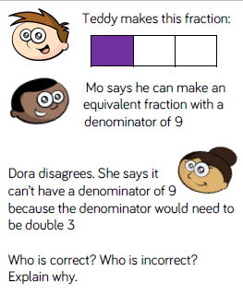
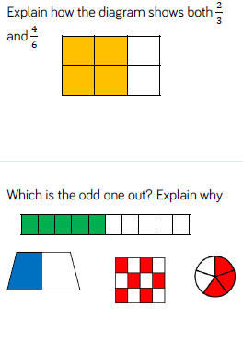
Reasoning and Problem Solving

