Measurement: Length and Perimeter
In these lessons, you will learn how to measure, compare, add and subtract: lengths (m/cm/mm); mass (kg/g); volume/capacity (l/ml).
Lesson 2 1. In this lesson, you will learn how to recognise that 100 cm is equivalent to 1 metre. Now, use this knowledge to convert other multiples of 100 cm into metres and metres into cm.
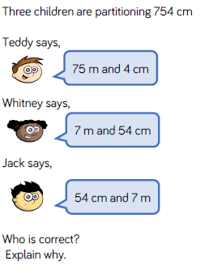
Solve these Reasoning and Problem Solving questions.
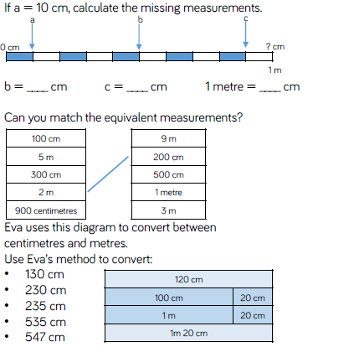

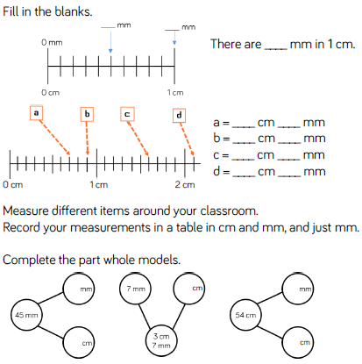

2. mm into cm
You will recognise that 10 mm is equivalent to 1 cm. Now, use this knowledge to convert other multiples of 10 mm into cm and cm into mm,

