Fractions Unit
Lesson One
Ordering Fractions
1. In this lesson, you will learn how to order fractions according to their value. The two types of fractions are called unit fractions and fractions with the same denominator. Both unit fractions and fractions with the same denominator show us how much of the whole we are talking about, but depending on the numerator and denominator, they show you different amounts.

Click on this link to support your learning and answer the questions on the BBC bitesize website: https://www.bbc.co.uk/bitesize/articles/z74gp4j

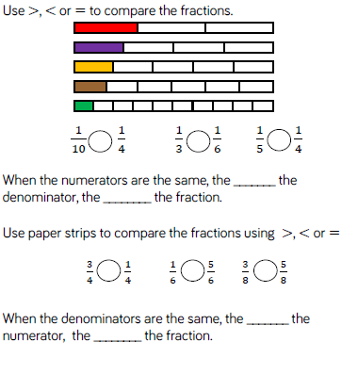
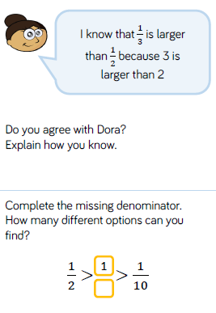
2. Now solve these problems

