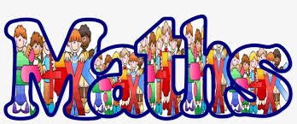

Geometry Unit
Drawing lines and shapes accurately
Lesson One
1. In this lesson, you will learn how to draw lines and shapes accurately using a ruler.
Click on this link to access your learning: https://www.bbc.co.uk/bitesize/articles/zcxy6g8
2. Now answer these questions below.
