Lesson Two Recognising 2D shapes
1. In this lesson, you will learn to recognise 2D shapes based on their properties. What are 2D shapes? 2D shapes are flat and all have different properties. E.G. windows are usually shaped like rectangles and clocks are shaped like circles.
Properties are the qualities that a shape has. Examples of shape properties are:
- number of sides
- number of angles (corners)
- length of sides
- types of angles (acute, obtuse, right-angle)
- perpendicular and parallel lines
Click on this link to access your learning: https://www.bbc.co.uk/bitesize/articles/zkhbp4j
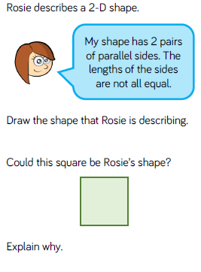
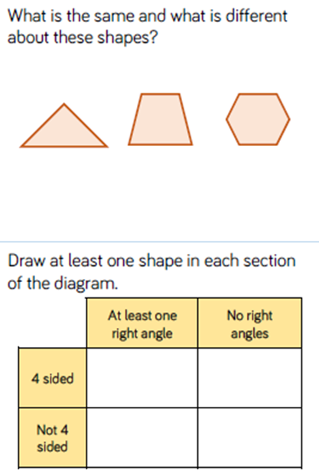
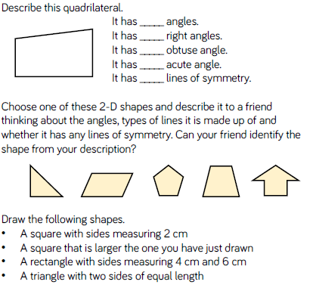
2. Now answer these questions below.

