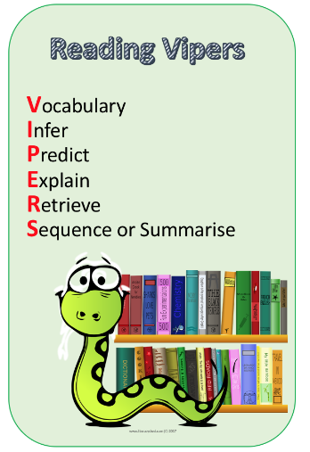
Max and the Millions by Ross Montgomery
Vocabulary
These words are from the novel study. Look up each word and find their definitions. Cheeky challenge: Write some synonyms and antonyms of each word
- Patrons
- Wiener
- Cunning
- Treacherous
- Remotely
- Pummel
Prediction
From the front cover predict what you think will happen in the story. Why do you think this?
………………………………..………………………………..………………………………..………………………………..………………………………..………………………………..………………………………..………………………………..
………………………………..………………………………..………………………………..………………………………..………………………………..………………………………..………………………………..………………………………..
………………………………..………………………………..………………………………..………………………………..………………………………..………………………………..………………………………..………………………………..
………………………………..………………………………..………………………………..………………………………..………………………………..………………………………..………………………………..………………………………..
Retrieve
Read this short passage. How would you draw Max from the description you have read?
Max is a 10-year-old orphan who has to wear two hearing aids. He goes to a boarding school where he has no friends his own age, because he finds communicating with the other boys too difficult.

Draw Max’s description in your Home Learning Books.

