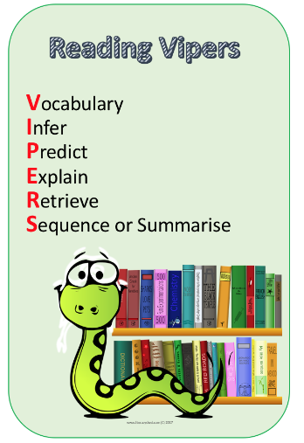
Max and the Millions by Ross Montgomery
Read Chapters 1-3
Answer the following questions
These words are from the novel study. Look up each word and find their definitions. Cheeky challenge: Write some synonyms and antonyms of each word
- Uncarpeted
- Lagoon
- Monuments
- Paradise
- Coincidence
- Cordoned
- Mournfully
- Grimaced
- Abolishing
- Dismantling
- Turrets
- Flourishes
- Clambered
- Bristled
- Voraciously
Chapter 2- Inference
(I) What type of headmaster is Mr Pitt?
(I) How did the children respond to Mr Pitt’s announcement of building on the football pitch?
Chapter 3-Explain
(E) Explain why the children speak to Max in a BIG LOUD VOICE?
(E) How does the author describe Sasha’s character?
(E) Explain what could have happened to Mr Darrow.

