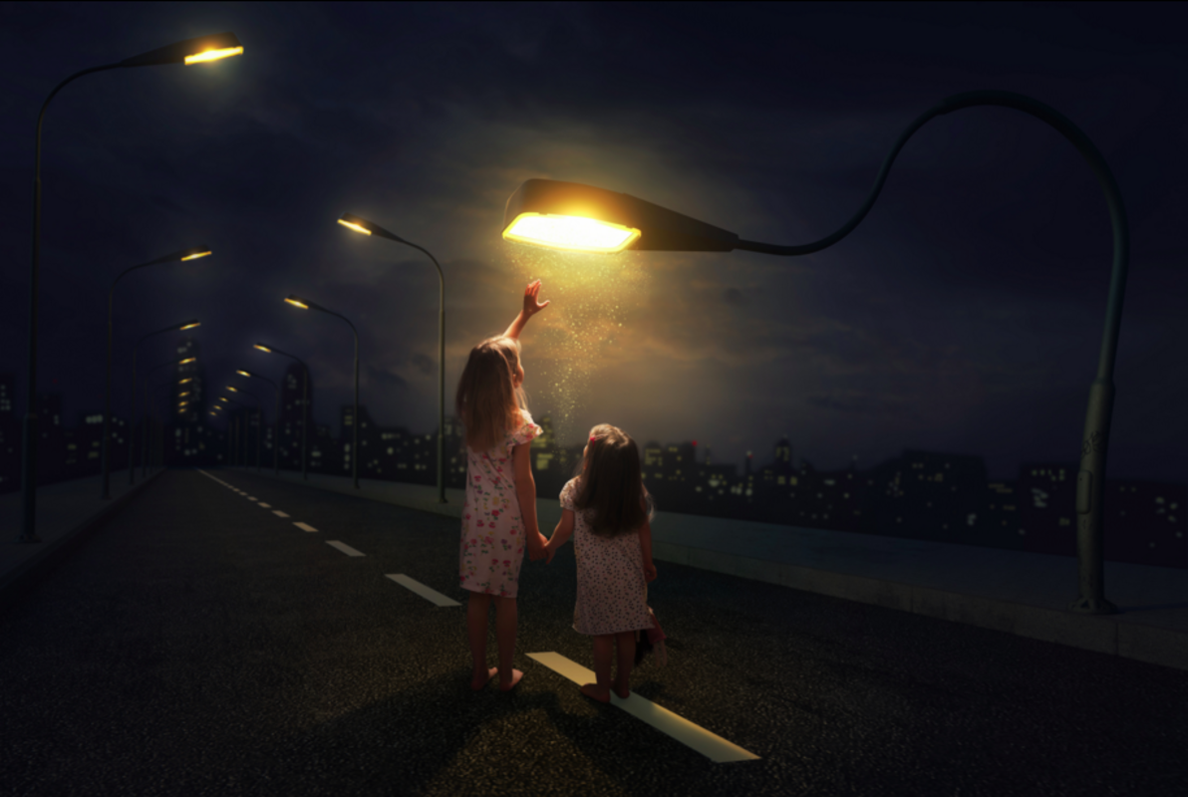

‘Magnetised’
Macy has magical powers.

Macy kept her powers secret. Not even her parents knew about the things she could do. Macy had known from a very young age that she was different, and although she was fascinated by the magic that she possessed, it frightened her. Her younger sister, Jenny, gripped her hand tightly. She was the only person that Macy had trusted with her secret, so far…
………………………………………………………………………………………………….………………………………………………………………………………………
………………………………………………………………………………………………….………………………………………………………………………………………
………………………………………………………………………………………………….………………………………………………………………………………………
………………………………………………………………………………………………….………………………………………………………………………………………
………………………………………………………………………………………………….………………………………………………………………………………………
………………………………………………………………………………………………….………………………………………………………………………………………
………………………………………………………………………………………………….………………………………………………………………………………………
………………………………………………………………………………………………….………………………………………………………………………………………
………………………………………………………………………………………………….………………………………………………………………………………………
………………………………………………………………………………………………….………………………………………………………………………………………
………………………………………………………………………………………………….………………………………………………………………………………………
………………………………………………………………………………………………….………………………………………………………………………………………
………………………………………………………………………………………………….………………………………………………………………………………………
………………………………………………………………………………………………….………………………………………………………………………………………
………………………………………………………………………………………………….………………………………………………………………………………………
………………………………………………………………………………………………….………………………………………………………………………………………
………………………………………………………………………………………………….………………………………………………………………………………………
………………………………………………………………………………………………….………………………………………………………………………………………
………………………………………………………………………………………………….………………………………………………………………………………………
………………………………………………………………………………………………….………………………………………………………………………………………
………………………………………………………………………………………………….………………………………………………………………………………………
………………………………………………………………………………………………….………………………………………………………………………………………
………………………………………………………………………………………………….………………………………………………………………………………………
………………………………………………………………………………………………….………………………………………………………………………………………
………………………………………………………………………………………………….………………………………………………………………………………………
………………………………………………………………………………………………….………………………………………………………………………………………
………………………………………………………………………………………………….………………………………………………………………………………………
………………………………………………………………………………………………….………………………………………………………………………………………
………………………………………………………………………………………………….………………………………………………………………………………………
………………………………………………………………………………………………….………………………………………………………………………………………
………………………………………………………………………………………………….………………………………………………………………………………………
………………………………………………………………………………………………….………………………………………………………………………………………
………………………………………………………………………………………………….………………………………………………………………………………………
………………………………………………………………………………………………….………………………………………………………………………………………
………………………………………………………………………………………………….………………………………………………………………………………………
………………………………………………………………………………………………….………………………………………………………………………………………
………………………………………………………………………………………………….………………………………………………………………………………………
………………………………………………………………………………………………….………………………………………………………………………………………
………………………………………………………………………………………………….………………………………………………………………………………………
………………………………………………………………………………………………….………………………………………………………………………………………
………………………………………………………………………………………………….………………………………………………………………………………………

