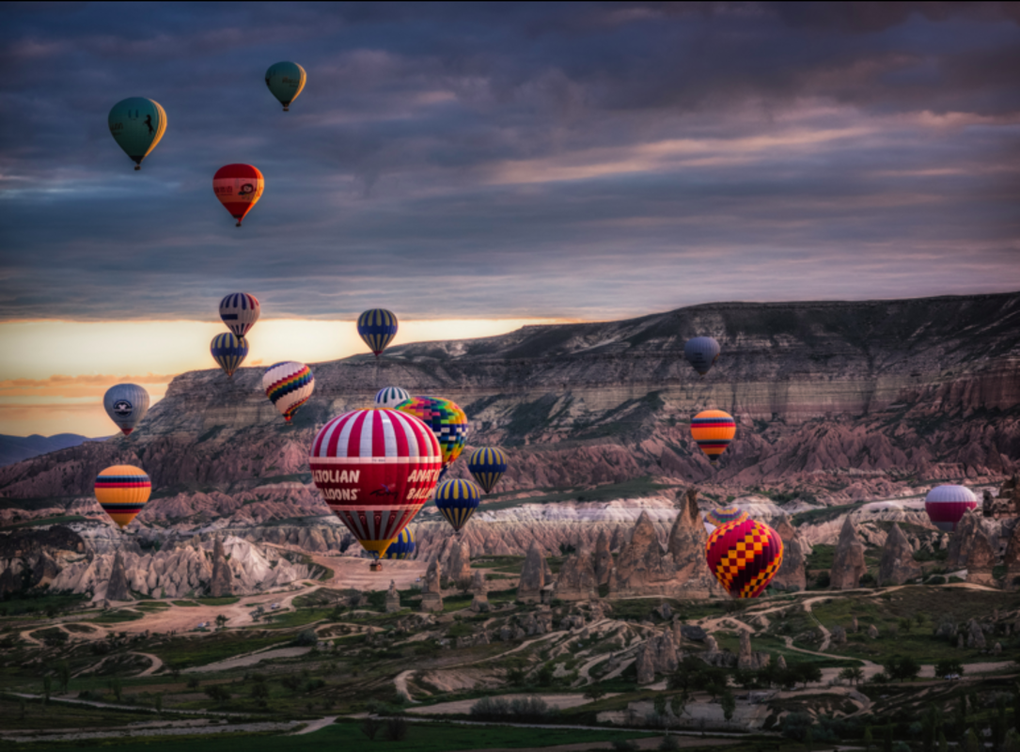

Around the World

Questions to support your writing

How many balloons do you think are taking part in the race?
What do the crews have to do to win the race?
What does the winner receive?
What obstacles might they encounter along the way?
How many of the crews will make it around the world?
How do you think the crews would prepare for such a journey?
What are the most dangerous things that they might encounter?

