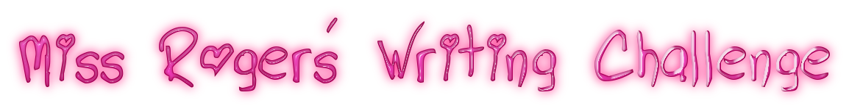
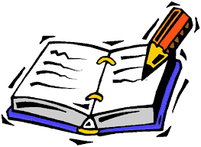

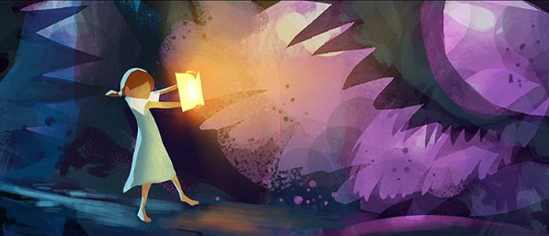
You can either draw this picture in your ‘home learning book’ or you can print off this picture.
Writing Challenge
Write a narrative (a story) about this picture.
Here are some questions to help you write your story
- What is the girl doing?
- Why is she holding the book like that?
- Why isn’t she wearing shoes?
- Why is the book glowing? Is it a normal book? What power does it have?
- How do the colours in this picture make you feel? Is there a safe place in this scene? An unsafe/dangerous place?
- Is she attacking or defending herself?
- Who else is in this scene (unseen by us)?
- Tell the before and after of this picture.
If you want to share these with me, you can send them via email.
You are all creative writers so have fun with this writing challenge!

