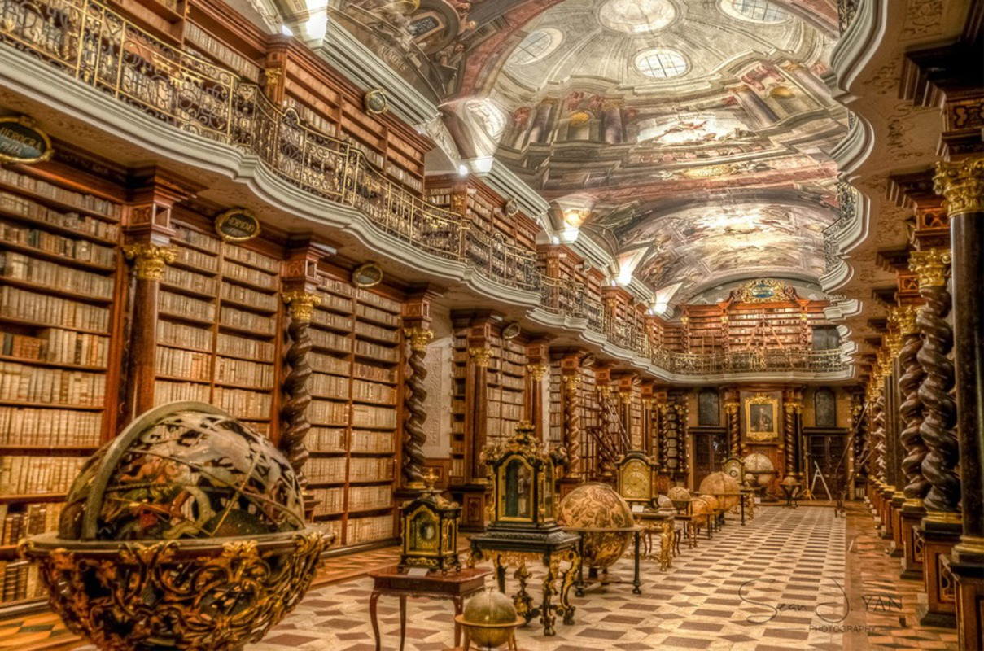

‘The Magic Library’
Story starter!
The Great House had many hidden treasures. As a 10-year-old girl, many of the rooms were out of bounds for Elsa, but her desire for adventure often got the better of her…
She peeked back over shoulder to check that the coast was clear. She could hear one of the butlers clattering around in the kitchens at the far end of the hall; no one knew she was there.
She carefully turned the ornate, golden door handle, hearing the mechanism inside clunk, and eased the heavy, wooden door open just enough to slip inside the room.
Immediately, Elsa was bathed in light as it poured down from the circular windows in the ceiling. She could see dust dancing in the beams of sunlight.
With a flutter of excitement inside her chest, she strode confidently into the centre of the room, her shoes click clacking off the chessboard-like floor. She loved this library – it felt like she was ‘in’ history. How many lords and ladies had graced this great room? It has stood here for centuries, and Elsa doubted that little, if anything, had changed over the years.
Elsa loved reading, but that was not why she had come to the library. She approached one of the golden orbs lined up along the centre of the library floor, and carefully placed her finger on the top. It had worked last time. Would it work again? She longed for the magic to happen, and closed her eyes in silent prayer…
Sentence challenge!
Verbs are action/doing words.
Can you identify all the verbs I have used below? Can you replace them with more interesting verbs?
Elsa walked bravely across the floor. Light came down from the windows. She looked back over her shoulder to see if anyone was there.

