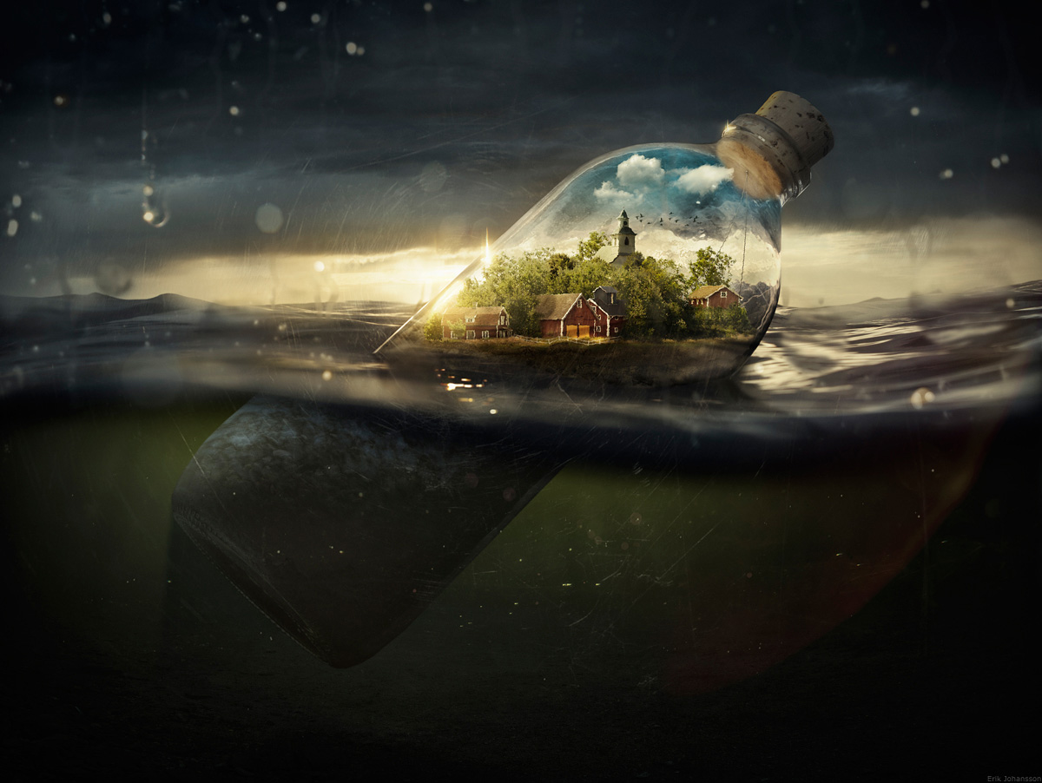
Drifting Away
Writing Challenge
Imagine you have been minimised to the size of an ant and you and everyone you know is now the size of an ant. You are drifting off to sea in this bottle, in a miniature world, just like The Borrowers. What does the world seem like from an ant’s point of view? Everything is gigantic in comparison to you and your little world in the bottle.

Task: Write a short narrative about the world around you from the perspective of your miniature self. What can you see? Are you afraid of the world around you? What can you explore in your miniature world? Where is the bottle taking you?
Questions to help you write:
- What can you see inside the bottle?
- What is that place?
- Is it a miniature village inside an ordinary-sized bottle, or an ordinary-sized village inside a giant bottle?
- Has it always been inside the bottle?
- Does anyone live there? Can they feel the waves of the water outside the bottle?
- How did the bottle get here?
- Where is it drifting away from/to?

