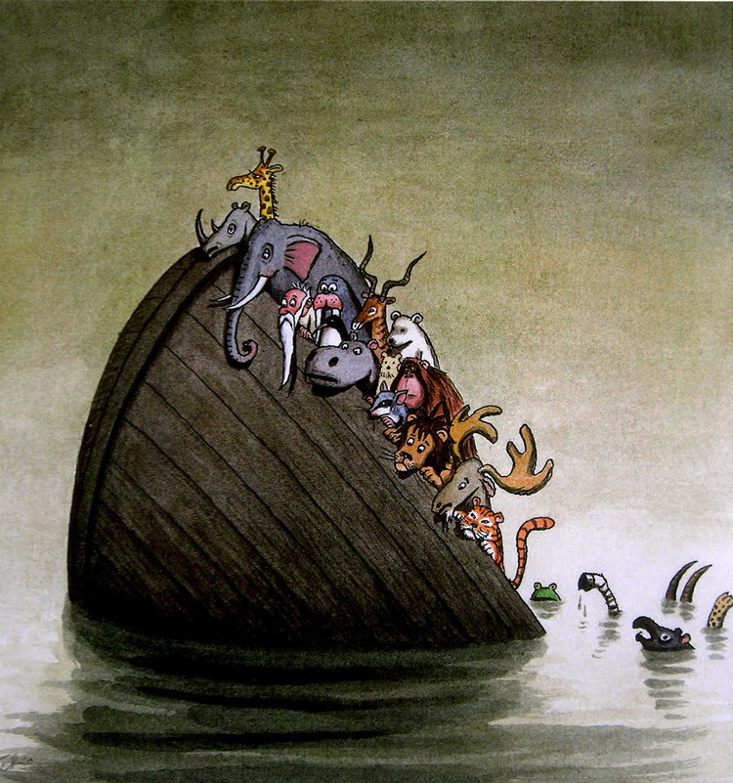
‘Sinking’
What has happened here?
Following on from reading Zoo by Anthony Browne write a narrative about this picture.
- How many animals can you see on the ark? How many animals can you see in the water?
- List the animals you can see.
- Why is the boat sinking?
- Why were the animals (and the man) on the boat in the first place?
- What do you think is going to happen? How could the boat be stopped from sinking?
- Share and explore the story of Noah’s Ark. Do you think this picture is showing the story of Noah’s Ark? Which part? Why can we only see one of each species?

