This term we will be looking at Adventure Stories, which is one of my favourite topics in English because of the many possibilities the stories could lead you. We will be looking at Alice in Wonderland as our first adventure story.
Writing Challenge
Imagine you come across a mysterious hole in a tree. You start to peer into it when suddenly you begin to fall. What can you see? Who do you meet? How would you walk around your new environment? How are you feeling?
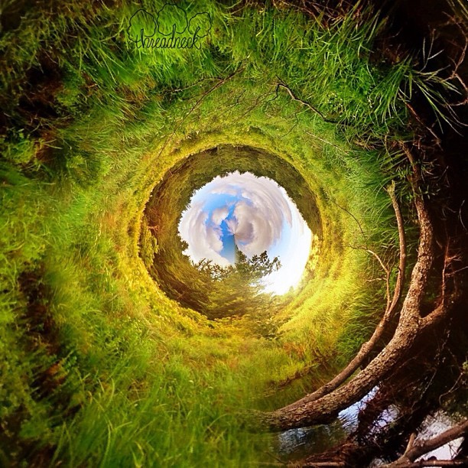
WAGOLL
Balancing onto the damp, wet ground Alice peered curiously into the abyss which lay before her. She knew exactly what she was going to do. She also knew almost immediately that this would be the wrong choice. Nevertheless, she knelt further and further down into the hole – her curiosity had gotten the better of her – and before she knew it she was almost completely submitted in darkness. Eagerly inching along the hole with anticipation Alice began to doubt her decision; it was becoming increasingly difficult to locate safe places to put her hands and she could feel her grip decreasing. All of a sudden the muddy banks gave way and she slipped head-first down into the midnight-black sea. Her body begin spinning around and around, twisting and turning, spinning and swirling. She attempted to take in her surroundings but she was gliding through the air at such pace all she managed was glimpses. Her pupils dilated at the wonderful and wild images which lay in front of her: grinning Chesire cats; stained glass windows; books stacked as high as the Eiffel tower; fluffy cotton-candy coloured trees; crumpled vases with intricate patterns. Not only could she see such unusual objects but she could hear unusual sounds! Whistling and howling like an army of monkeys ready to pounce circled her body whilst a constant buzzing seemed to follow her as she travelled uncontrollably down the hole.

