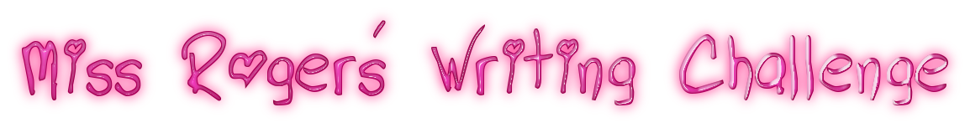
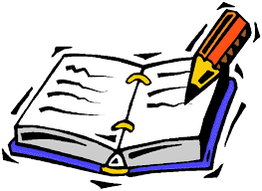

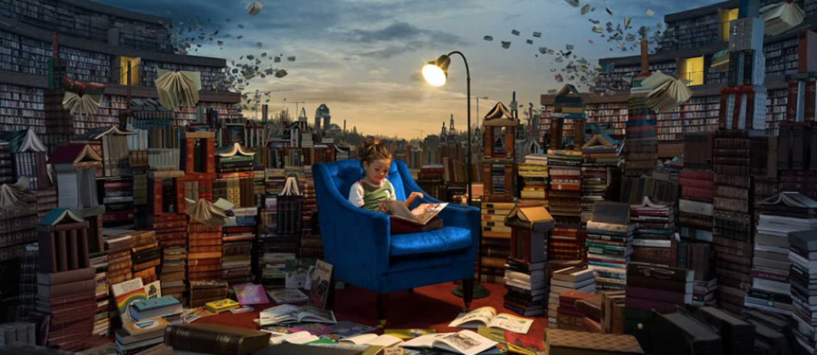

Writing Challenge
Using this picture as a stimulus (a prompt) and using expanded noun phrases, following on from your English lesson from today (05.05.20), write a short story.

The Greatest Library
The books had minds of their own…
This was no ordinary library.

Books about knights and castles would gallop all over the library, bravely and boldly ordering the other books around. The books about thieves would sneak around, lurking behind bookshelves in the shadows. Books about wild animals would occasionally roar and bite other books. The ones containing stories set in the winter would often shiver, covering their neighbours with snow and frost.

Lucy loved this place like no other. Reading was the most exciting thing in the world here: everything she read seemed to come alive out of the pages…
Can you continue this story about The Greatest Library?

