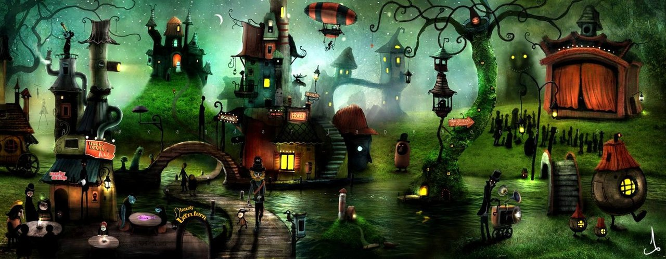
Writing Challenge

Strange Town
Key questions to support your writing
- Do you think the inhabitants of strange town are like you or I?
- They certainly look different, but does that really make them different? How might they be similar to us?
- What do you think each of the buildings in Strange Town are used for?
- How many different lights can you see in the picture? Can you identify what each light might be used for?
- One of the characters in the picture is the Mayor of Strange Town. Who do you think it is?
- If you met one of the inhabitants of Strange Town, what 5 questions would you ask them?
Story starter!
It was an ordinary night, but this was no ordinary town. This was Strange Town. During the day, everything was quiet. It came alive at night. Now that darkness had fallen, and a silvery, pale crescent moon and millions of twinkling stars gazed down from above, people gradually began to emerge from their houses. But…were they people at all? They certainly didn’t look like people. They were like their houses: all sorts of shapes and sizes. Irregular. Odd. Passers-by always ‘tut-tutted’ as they passed Strange Town, not understanding its ways or its inhabitants. One thing could be said of the goings on in Strange Town, however: there was never a dull moment…

