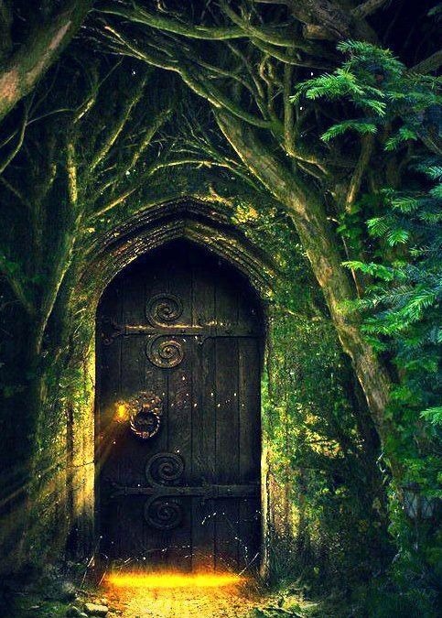
Through The Door

Write a short story to tell Miss Rogers what lies beyond the door. Remember to use expanded noun phrases (The rigid, rusty door handle creaked open. What lie beyond the door was unspeakable)!

Key questions to support your writing

- Where do you think this is? Draw/imagine what is around you.
- Where does the door lead to?
- Does it always open to the same place?
- What is the glow coming from the other side?
- Do you think anyone else has ever been here? Why do you think that?
- Would you go through the door? Why? Convince me that I should/shouldn’t open it.
- If the door could talk, what would it say?

