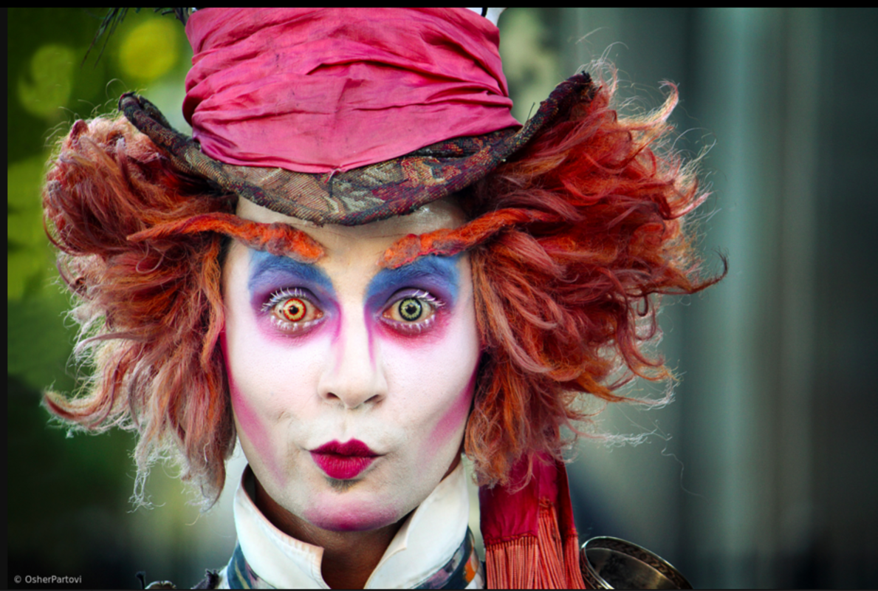
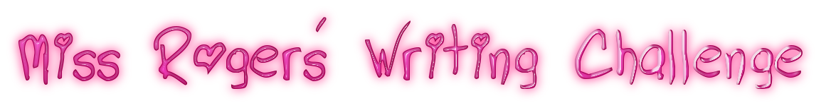

‘The Mad Hatter’
Can you write a character description of the Mad Hatter?
Story Starter!
He was a most peculiar looking chap…

Key Questions to think about
Who is the Mad Hatter?
Which book is the Mad Hatter a character from?
Which other characters from the book do you know/can describe?
What might the Mad Hatter be looking at?

