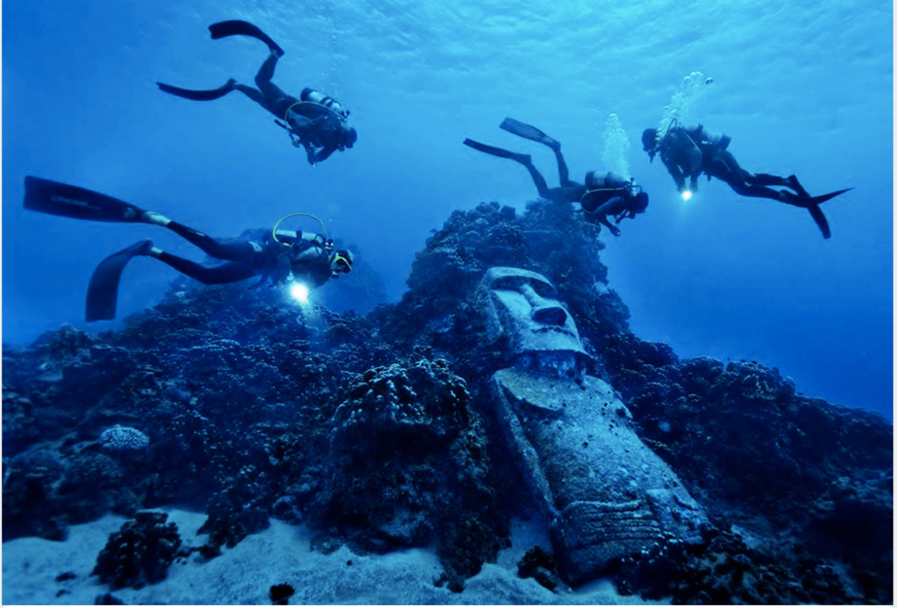

‘Lost and Found’
What have you discovered?
Imagine you are one of the divers making the discovery.
What else will you find buried underneath the sand?
Draw and describe what you have imagined. Could it be something from the Stone Age?

Steps to Success
- Use expanded noun phrases to up level your work
- Use fronted adverbials to start your sentences
- Up level your words by using the thesaurus, think of different synonyms for the words you choose
- Remember capital letters and sentence finishers (. ! ?)

