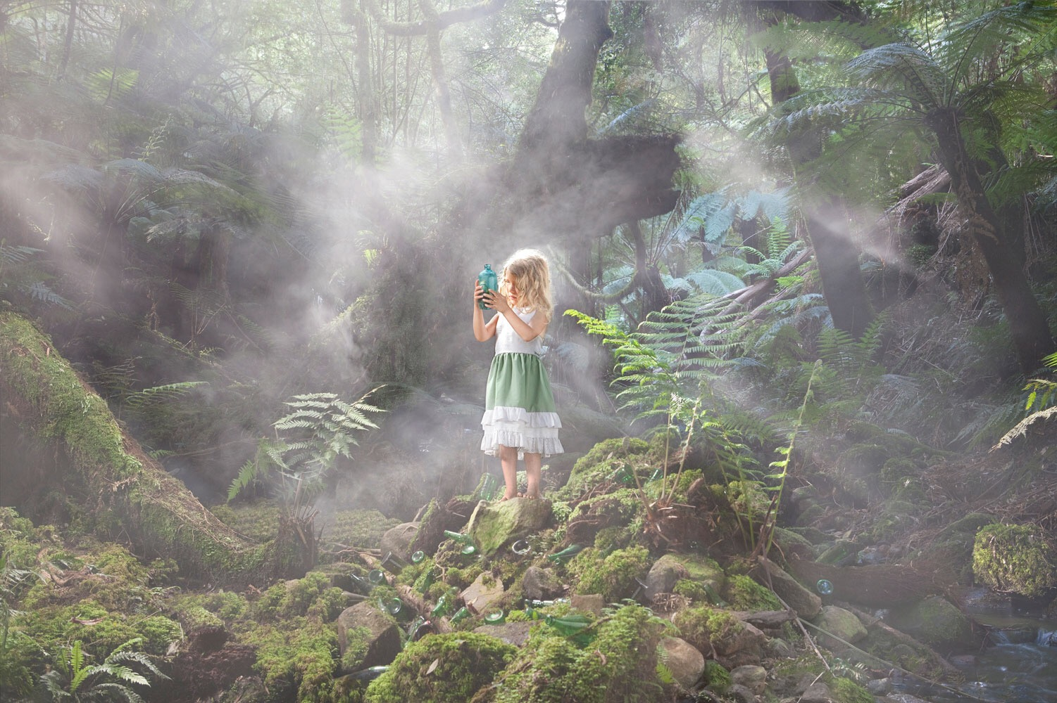
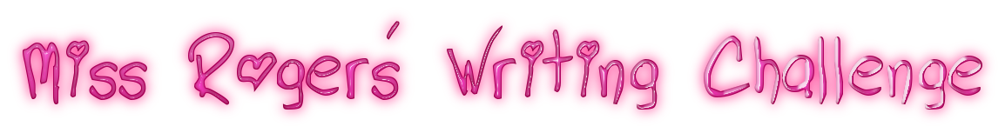
‘What is inside the bottle?’
Writing Challenge
What is inside the bottle? Imagine you have picked up this bottle in the middle of nowhere. What can you see in the bottle?
Task: Write a narrative about how this little girl came to find this bottle. What could possibly be inside it? You can either write the story from the perspective of the girl or you could write in third person.
Questions to support your writing:
- What is the girl doing?
- Where did the bottle come from?
- What is inside it?
- What is she going to do with it?
- What else can you see around her feet? How did the other bottles get there?
- Why is she in the woods?
- What would you do if you found a bottle in the woods?

