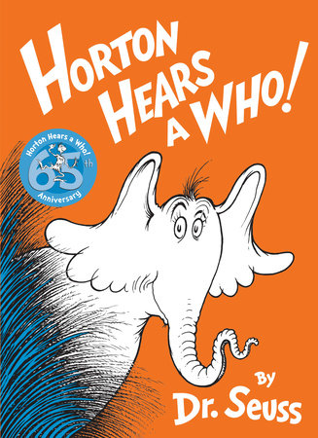
Kindness Week
This week it is Kindness week in school. Listen the story of Horton Hears a Who on youtube. What does the word Kindness mean to you? https://www.youtube.com/watch?v=B-i1E1UbwVI One day Horton, with his very big ears, hears a tiny yelp for help coming from a speck. The other jungle animals don’t know what he’s talking about, and they want to destroy the speck. Thus begins Horton’s epic journey to save the Whos. This classic Dr. Seuss tale is such a great way to teach kids that kindness is persistent and that any person, or elephant, can stand up for those who can’t stand up for themselves.
Reading Task
1. Where did Horton place the dust speck that he found?
…………………………………………………………………………………………………………………………………………………………………………………………
…………………………………………………………………………………………………………………………………………………………………………………………
2. What is the name of those living on the dust speck?
…………………………………………………………………………………………………………………………………………………………………………………………
…………………………………………………………………………………………………………………………………………………………………………………………
3. Which animals did not believe Horton’s dust speck had voices?
…………………………………………………………………………………………………………………………………………………………………………………………
…………………………………………………………………………………………………………………………………………………………………………………………
4. How do you think Horton felt when his clover was thrown into the giant patch of clovers?
…………………………………………………………………………………………………………………………………………………………………………………………
…………………………………………………………………………………………………………………………………………………………………………………………
5. Why do you think no animals’ believed Horton?
…………………………………………………………………………………………………………………………………………………………………………………………
…………………………………………………………………………………………………………………………………………………………………………………………
6. Horton never gave up because he believed that a person’s
………………………………………………………………………………………………………………………………………………………………………………………………………………………………………………………………………………………………………………………………………………………………………………………………………………………………………………………………………………………………………………………………………………………………………………………………………………………
7. What was the final sound that made the Whos heard?
………………………………………………………………………………………………………………………………………………………………………………………………………………………………………………………………………………………………………………………………………………………………………………………………………………………………………………………………………………………………………………………………………………………………………………………………………………………………………

