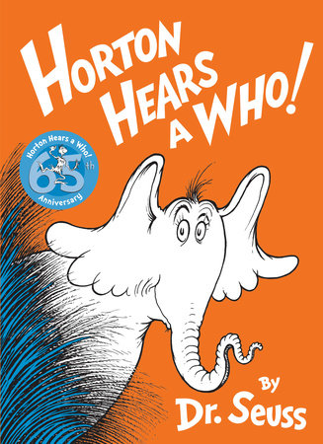
Kindness Week
This week it is Kindness week in school. Listen the story of Horton Hears a Who on youtube. What does the word Kindness mean to you? https://www.youtube.com/watch?v=B-i1E1UbwVI One day Horton, with his very big ears, hears a tiny yelp for help coming from a speck. The other jungle animals don’t know what he’s talking about, and they want to destroy the speck. Thus begins Horton’s epic journey to save the Whos. This classic Dr. Seuss tale is such a great way to teach kids that kindness is persistent and that any person, or elephant, can stand up for those who can’t stand up for themselves.

Description Task
- Read the story and pause at different points to discuss how Horton is feeling. Could you think of questions to ask him at that point?
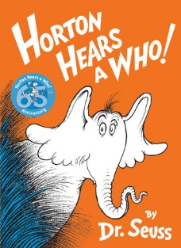
- How would you describe this character?

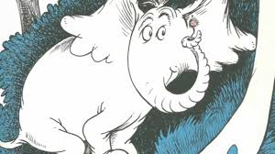

Retrieval/Vocabulary Task
Look through the text and find different synonyms for 'said' can you think of your own synonyms for ‘said’?
