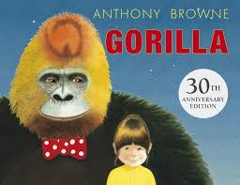
Reading
Gorilla by Anthony Browne
In Year 3, we are still focusing on Anthony Browne’s books. This week’s book is called Gorilla. Hannah loved gorillas. She read books about gorillas, she watched gorillas on television, and she drew pictures of gorillas, but she had never seen a real gorilla. Her father did not have time to take her to see one at the zoo. He did not have time for anything. Read this book and answer the VIPERs questions below.
Read the book online: https://fliphtml5.com/xjqt/yloh/basic or listen on youtube: https://www.youtube.com/watch?v=DsZn210fGWo
Summarise
Why does Dad have a banana in his pocket? Could he have been the gorilla? Was Hannah really dreaming? How does Hannah feel now compared to the start of the book?
…………………………………………………………………………………………………………………………………………………………………………………………
…………………………………………………………………………………………………………………………………………………………………………………………
…………………………………………………………………………………………………………………………………………………………………………………………
…………………………………………………………………………………………………………………………………………………………………………………………
…………………………………………………………………………………………………………………………………………………………………………………………
…………………………………………………………………………………………………………………………………………………………………………………………
…………………………………………………………………………………………………………………………………………………………………………………………
…………………………………………………………………………………………………………………………………………………………………………………………
…………………………………………………………………………………………………………………………………………………………………………………………
…………………………………………………………………………………………………………………………………………………………………………………………
…………………………………………………………………………………………………………………………………………………………………………………………
…………………………………………………………………………………………………………………………………………………………………………………………

