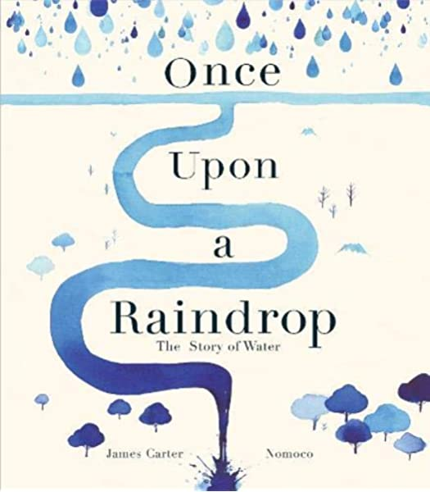
6th July
Reading
Listen to “Once Upon a Raindrop: The Story of Water” by James Carter https://www.youtube.com/watch?v=raXENZYwWXc
Vocabulary
Oceans, rivers, streams, shore, meteorites, ablaze, sky-borne, lakes, waterfall, water cycle, pouring, trickling, vapour, liquid, rehydrate, gravity
1. Write the definitions for each of these words.
2. Look to see if these words have synonyms and antonyms.

Learning Question
What is this book about?

Outcomes
1. Chrn to explore the imagery in the book
- To build up a word bank of descriptive language to describe the images in the book.
2. Chrn to reread the story and summarise the key points

- Chrn to story path the story focusing on the key aspects of the story

Task: Re-read the story and summarise the key points
- Story path your ideas to summarise the story
- Remember to caption your story path

