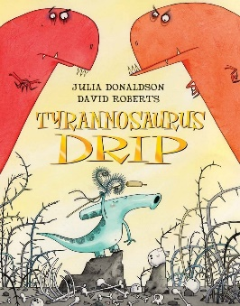
Retrieve information from a text

Tyrannosaurus Drip Reading Comprehension Questions

Where did the duckbill dinosaurs live?
__________________________________________________________________________________________________________________________________________________________________________________________________________________

Why was Mother T horrified by baby number three?
__________________________________________________________________________________________________________________________________________________________________________________________________________________

Why did his sisters call him Tyrannosaurus Drip?
__________________________________________________________________________________________________________________________________________________________________________________________________________________

Why did Drip run away from home?
__________________________________________________________________________________________________________________________________________________________________________________________________________________

How was Drip different to his sisters?
__________________________________________________________________________________________________________________________________________________________________________________________________________________

