Tuesday 5th May 2020
Spelling Task: words with ‘ough’ in
Spellings with ‘ough’ in to learn are:
bough cough enough bought thought though through plough drought sought
- Quick Quiz- ask someone at home to give you a quick quiz on these words so that you can see which ones you can already spell and which ones you need to practise.

- Look at each of the words. How de we pronounce each of the words? Say the words out loud.

- Read the poem: The ‘ough’ Poem (attached) Find the words with ‘ough’ in. Are the words pronounced in the same way? What different sounds does the ‘ough’ make in the words?
Add the words into a grid like the one below to show the different sounds the ‘ough’ makes?

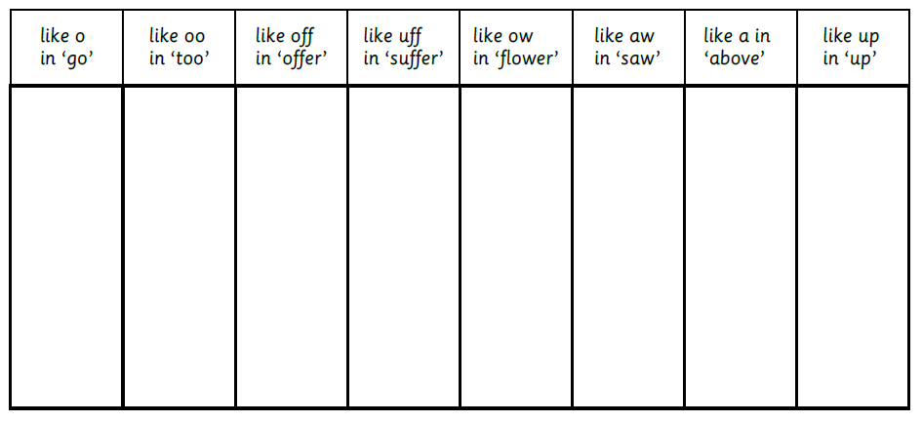

Challenge: Find 3 more words with ‘ough’ in to add to each column.

- Quick Activity: Write out each word with ‘ough’ in (from the top of this page) as many times as you can in 30 seconds.
This will help you to learn to spell the words by promoting your muscle memory!

- Quick Quiz – How many of our words can you now spell accurately?

