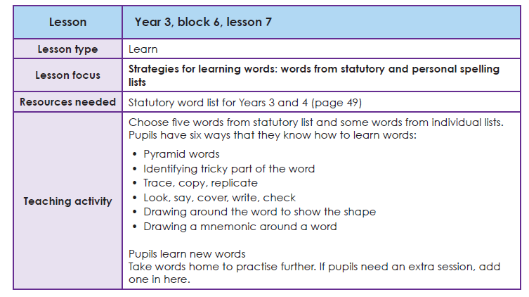

Task 1 Learning your spellings
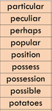
Use your ‘Spelling Journals’ to write the words from this list. You can use any spelling strategy to help you learn them.

Task 2 Write these words into sentences
E.G. Is it possible to possess magical powers?

