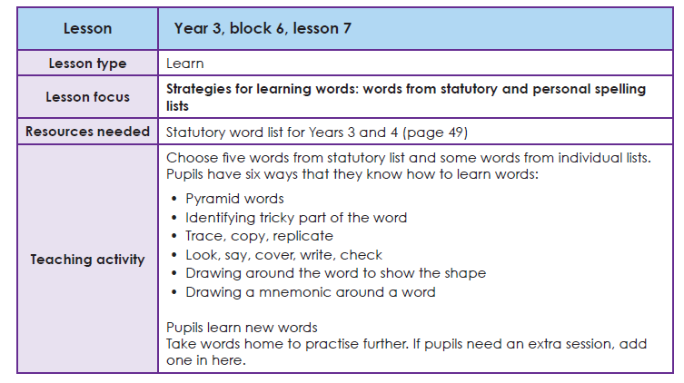

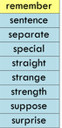
Task 1 Learning your spellings
Use your ‘Spelling Journals’ to write the words from this list. You can use any spelling strategy to help you learn them.

Task 2 Write these words into sentences
E.G. I remember feeling extremely strange when I woke up from a nightmare.

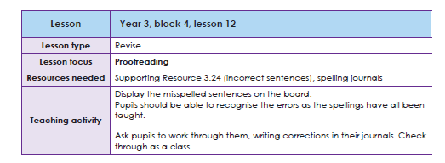
Task 3 Proofreading
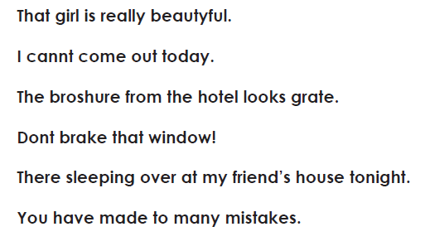
Read the sentences below. Look at the words that are misspelt. Remember the spelling rules. Rewrite the sentences with the words spelt correctly.

