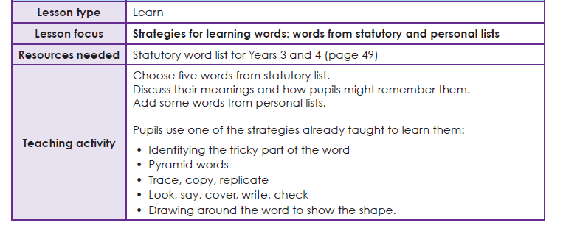
Year 3 Spelling list
Use your ‘Spelling Journals’ to write 5 words from this list. You can use any spelling strategy to help you learn them.
