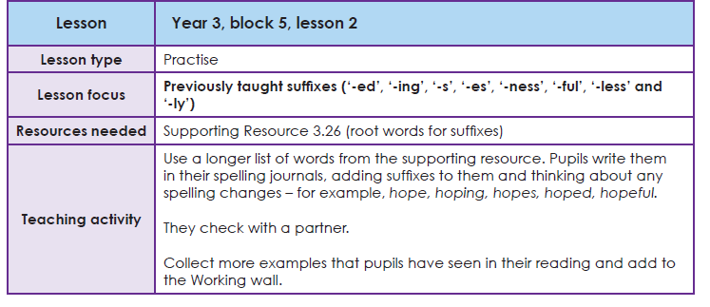
Suffix endings
A suffix is a string of letters that go on the end of a word (root word), changing or adding to its meaning.
Task 3
Suffix endings: (-ed, -ing, -s, -es, -ness, -ful, -less, -ly)
Your task is to add the right suffix ending onto the end of these words. There may be more than one suffix that you need to add.
Root words
