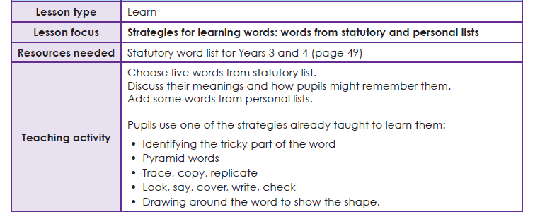

Year 3 Spelling list
Task 1 Learning your spellings
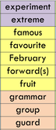
Use your ‘Spelling Journals’ to write the words from this list. You can use any spelling strategy to help you learn them.

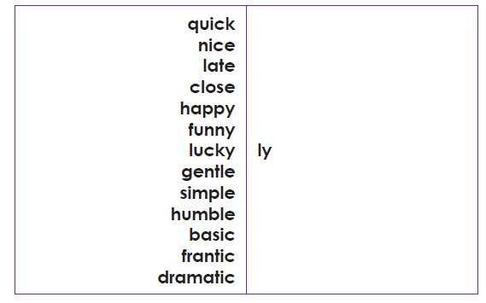
Task 2 Suffix endings ‘ly’

- Write down all the words with the suffix ending –ly
- Pick 5 words with their suffix ending –ly and put them into 5 sentences (remember to underline the suffix in the sentence)
EG: I closely watched the pasta cook, so it didn’t boil over and cause a mess.

