Week beginning June 29th
Maths Challenge 1
Can you match my value?
What coins could you use to match my value? Find two different ways for each value.
Use real coins, the cut out coins or draw the coins in.
14p | 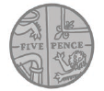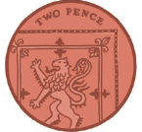
23p
28p
35p
46p
57p

