Week beginning- 8th June
Maths Challenge 1
How many are there altogether?
Using a number of identical objects (20 or more) toy cars, buttons, pasta pieces etc…
Make equal groups of 2, 5 or 10.
There are __ pieces in each group.
There are __ groups.
There are __ pieces altogether.
Get your child to organise the items into equal groups & ask you the same question. Model counting out the total number of items in the groups. Repeat until this process is easy (using different number for the groups).
- How many are there altogether?
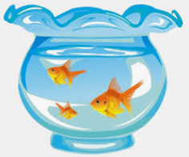
There are__ fish in each bowl.
There are __ bowls.
There are __ fish altogether.
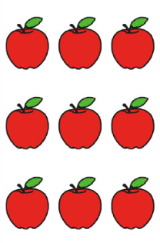

There are__ apples in each row
There are __ rows.
There are __ apples altogether.

- Can you draw your own equal groups of objects and answer the questions about them?

