Week beginning June 22nd^{th}
Maths Challenge 1
What 3d shapes can you see around you?
This week we will be identifying and describing different3d shapes.

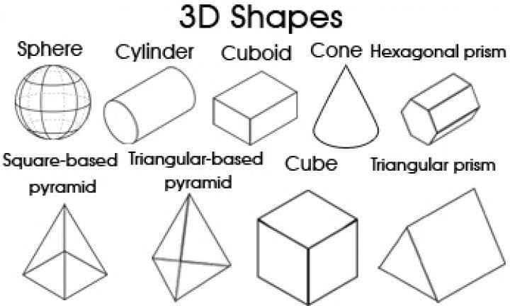

- Shapes are all around us. Go on a shape hunt and see which 5d shapes you can find.

- What sort of 3d shapes can you see most of?

- Are there any 3d shapes that it is hard to find?

3d shape | Object
cuboid | cereal box

