Week beginning June 29th
Maths Challenge 2
What is my total?
Use coins to make different amounts and count the totals.
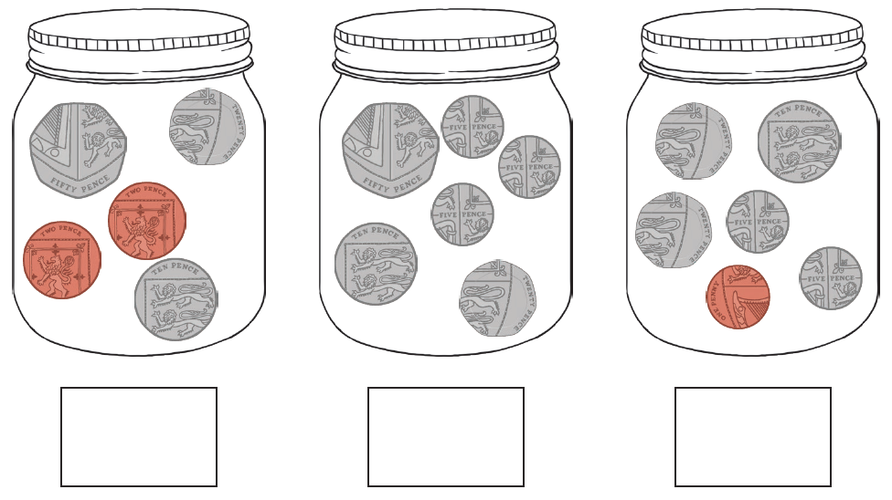
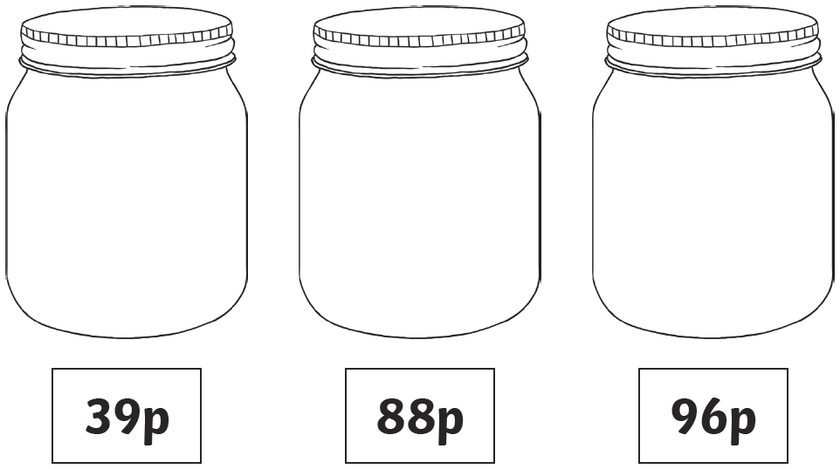
- Using 2 sets of coins calculate the totals and explain how you know which one is the largest amount.
- Using 3 sets of coins count the totals and then sort into largest, smallest and medium value totals.

