Week beginning 15th June
Maths Challenge 3
How many in each group? How many in total?
- Today we are going to be counting groups of things and counting the total (how many there are altogether).
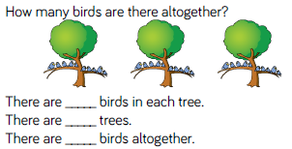
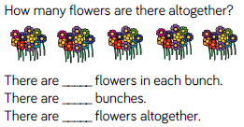
- Can you make a counting in tens number line?
Start with zero and use ten counters if you need to.
- Count in tens to 100. Can you count ten more than 100? Use your counters if you need to.
- Can you count backwards in tens from 100?
- Can you count in tens forwards or backwards from any of the numbers on your tens number line?
- Can you count forwards or backwards from any number without looking at the number line?

