Week beginning 6th July
Maths Challenge 4
Can you correct the time?
Mrs Tomlinson says that it’s half past eight. Is she correct? Explain why.
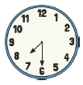 | ----------------------  ----------------------

Mrs Parsons says that it’s twelve o’clock. Is she correct? Explain why.
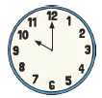 | ----------------------  ----------------------

Mr Eden says that it’s 7 o’clock. Is he correct? Explain why.
    

